

**Birzeit University**

**Faculty of Engineering and Technology**

**Department of Electrical and Computer Engineering**

**ENCS3320 – Computer Networks**

**Project #1 (Socket Programming) – Due Thursday, November 28, 2024**

member names, and IDs

Dania Dar-Alhaj (1212179 section 5)

Yosra Shilo (1200867 section 5)

# **Project #1 (Socket Programming)**

## **Introduction**

This project involves three key tasks aimed at implementing a robust network-based solution. that we have three tasks . Task 1 foucus to implemantation the commands , while Tasks 2 and 3 focus on developing a server-client architecture using standard socket functionalities.

## **1. Task 1**

### **1.1 explain commands**

#### **1.1.1 ipconfig command**

It's displays network configuration details for of the current device . It shows the IPv4 and IPv6 addresses , The subnet mask , The default gateway. and this command useful for troubleshooting and verifying network settings .

#### **1.1.2 ping command**

it's tests the connectivity between particular device and a target host like a server or website, by sending data packets and waiting for a response. It reports the time taken for each packet to travel and the packet loss rate,. If the host responds, it confirms that the network connection is active. If not, it may indicate a network problem or that the target is unreachable .

#### **1.1.3 tracert command**

It’s maps the route that data takes from a particular device to a target host . It sends packets to the destination and records each hop the packets pass through along the way. helping identify where delays or disruptions occur in the network path. This is useful for diagnosing or connectivity issues happen .

#### **1.1.4 telnet command**

It’s used to connect your device to another server using the Telnet protocol, allowing you to execute commands on the remote server. And allows your device to establish a connection with a remote server using the Telnet protocol, enabling command execution on the server.

#### **1.1.5 nslookup command**

It’s used to retrieve information about domain names (DNS), such as the IP address associated with a particular domain. And retrieves details about domain names (DNS), such as their associated IP addresses or mail server records.

### **1.2 run commands**

#### **1.2.1 ipconfig /all command**

ipconfig /all offers a more detailed report, showing additional information more than ipconfig like the MAC address, DHCP statu, DNS servers... . While ipconfig is useful for quick checks, ipconfig /all is more comprehensive, providing everything needed for deeper network troubleshooting .

By running the ipconfig /all command on my device I got the following results :

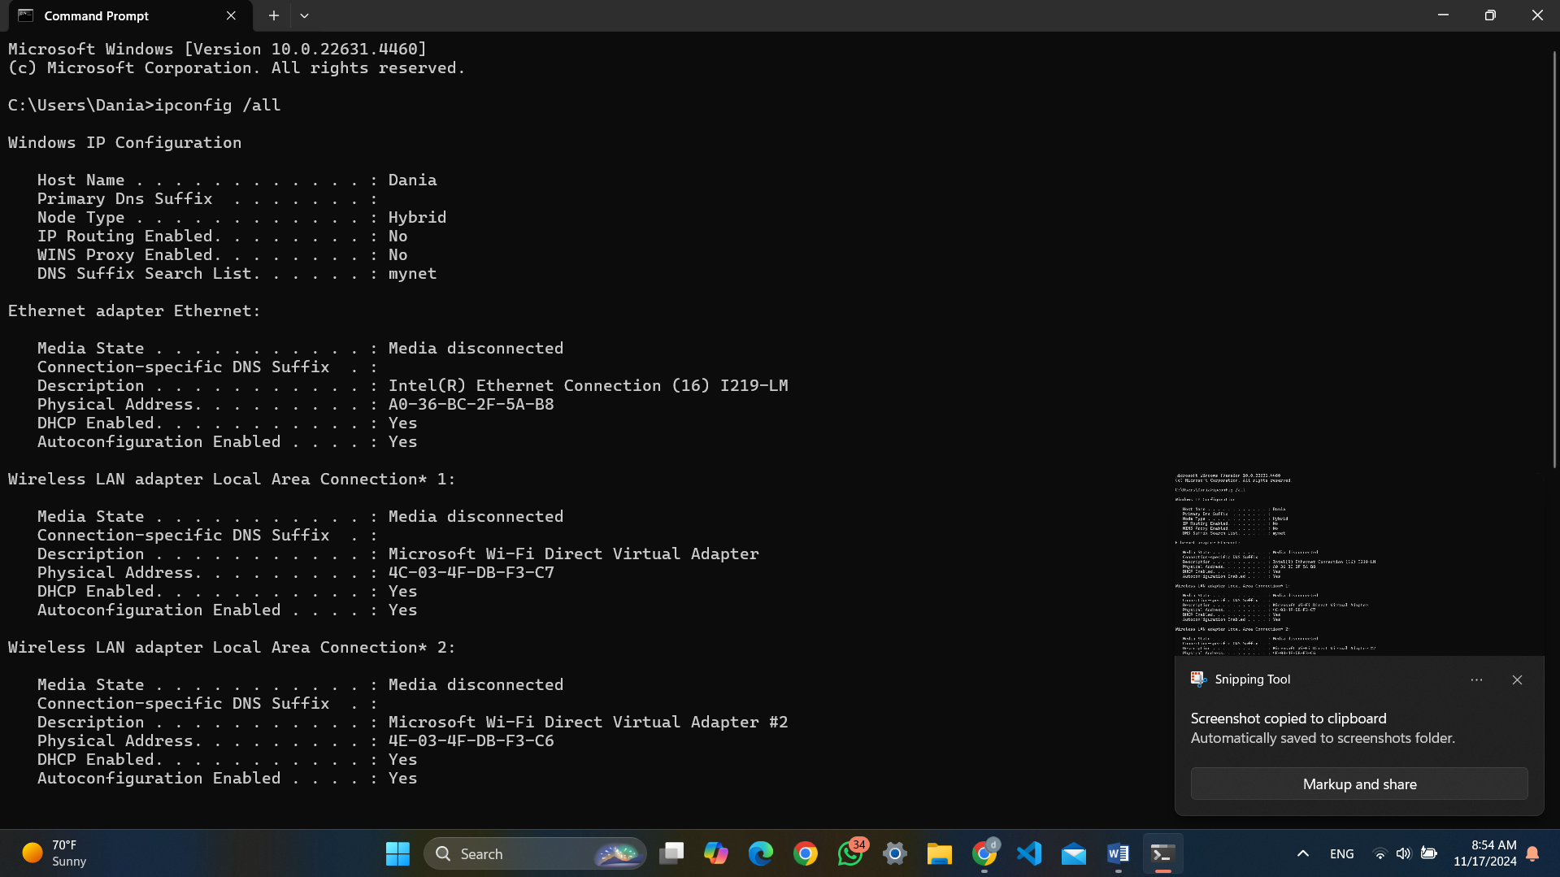figure(1) ipconfig /all

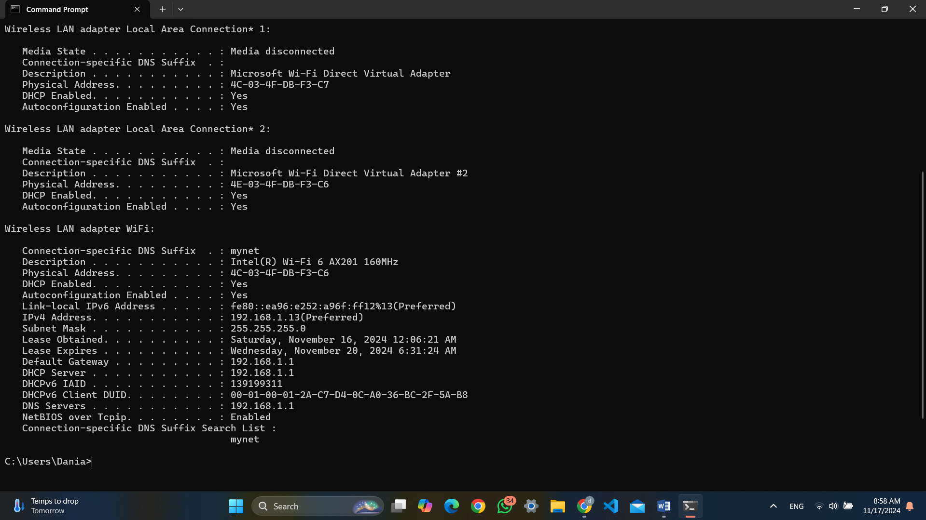figure(2) ipconfig /all

So according to this results

IP address: 192.168.1.13

subnet mask : 255.255.255.0

default gateway: 192.168.1.1

Domain Name System (DNS) server: 192.168.1.1

#### **1.2.2 Ping a device**

To ping a device on the same network I need to get ip address for it the ping ip address

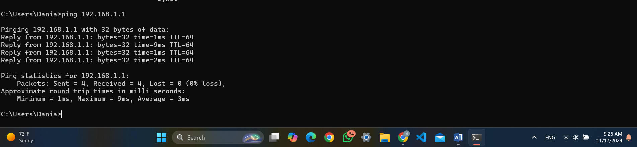

figure (3) ping a device

According to the results that I get this is mean the ping result is successful and the network connection is active

#### **1.2.2 Ping a website**

#### figure (4) ping wepsite

i can see the responses showing the time taken for each packet to travel to the website and back and the ping request to the website was successful so that this is mean there are no network issues preventing access

#### **1.2.3 Run tracert**

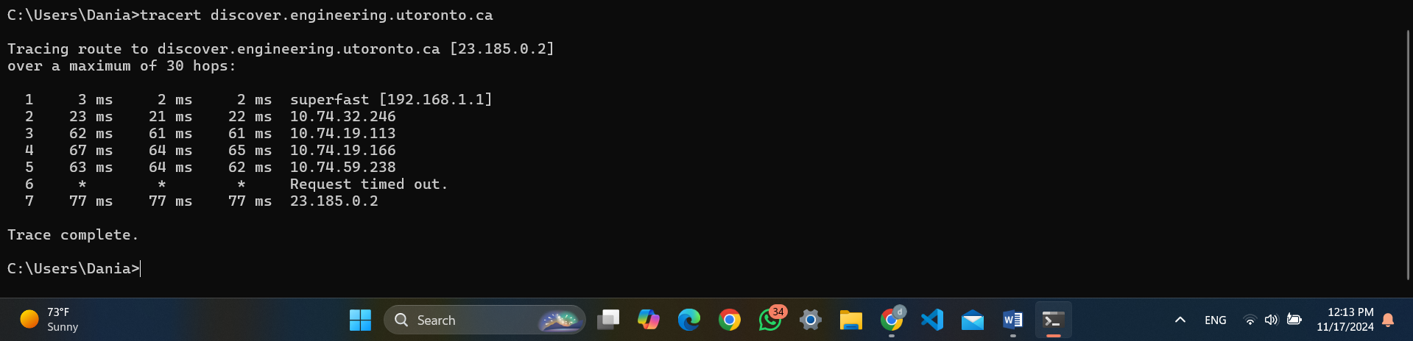figure(5) run tracert

according to The results The trace starts from my local router IP 192.168.1.1) , and the tracert command show the path taken by data packets to reach the destination discover.engineering.utoronto.ca (IP address 23.185.0.2).and moves through several network hops, each round-trip times. At hop 6, a timeout occurs and, the trace successfully reaches the destination

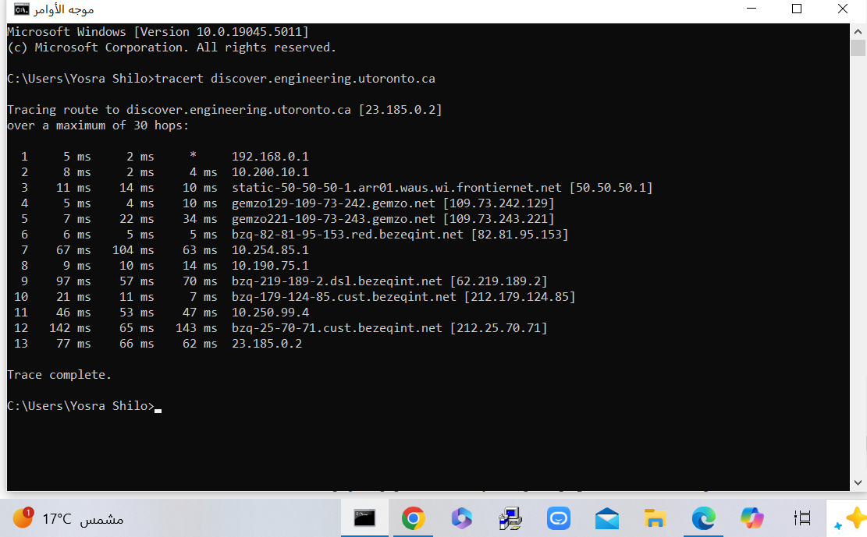 figure(6) run tracert2

successfully traced the route to the target server across 13 hops. The final server at 23.185.0.2 is reachable, with a latency of around 62–77 ms. Each hop represents a point the packets traveled through, with increasing latency as the distance increases. The presence of ISPs and backbone networks suggests the route involves multiple network providers before reaching the target.

#### **1.2.4 Use nslookup**

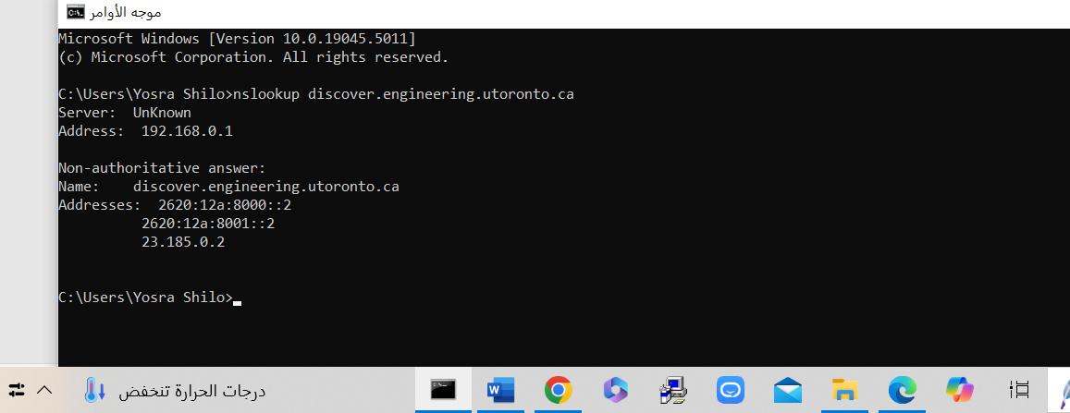figure(7) run nslookup

The DNS query successfully retrieved both IPv6 and IPv4 addresses for discover.engineering.utoronto.ca.

The nslookup command successfully retrieved the IP addresses for discover.engineering.utoronto.ca.

* IPv6 addresses: 2620:12a:8000::2, 2620:12a:8001::2
* IPv4 address: 23.185.0.2

This confirms that the domain resolves to these addresses and is reachable via both IPv4 and IPv6.

#### **1.2.5 telnet**

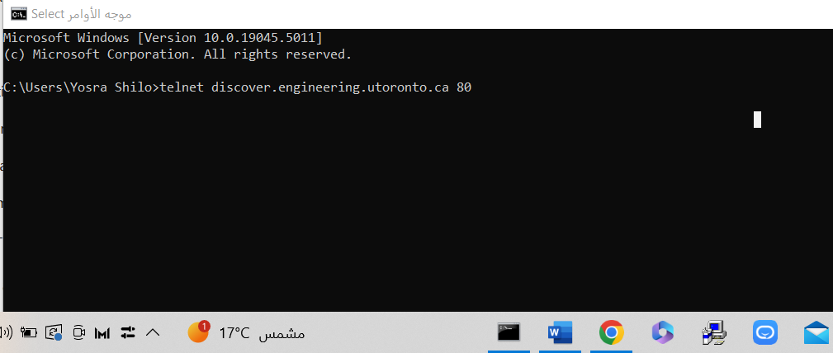figure(8) run telnet

telnet discover.engineering.utoronto.ca 80  
is attempting to connect to the server discover.engineering.utoronto.ca on **port 80** using Telnet.

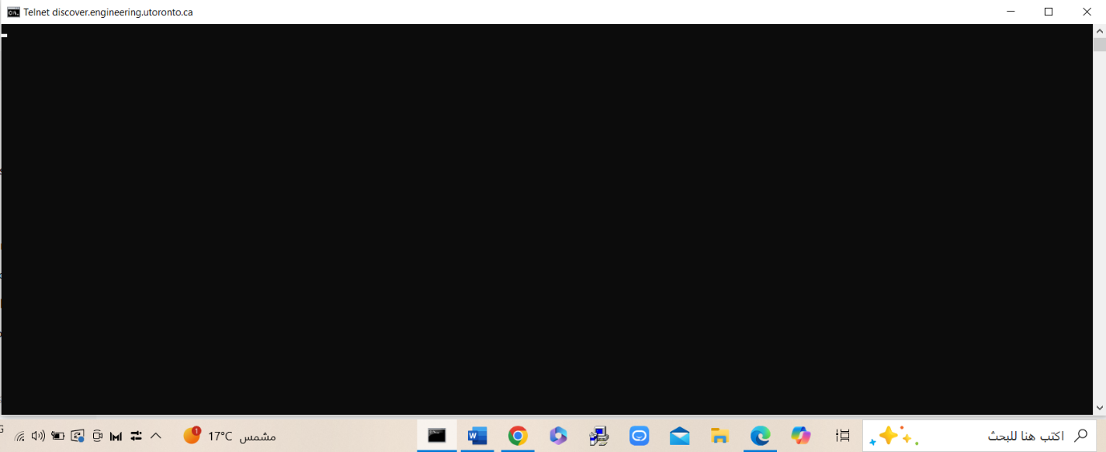figure(9) run telnet

a blank screen appears, it means the connection was successful.

This indicates that the Telnet command successfully connected to the specified server and port, but since Telnet doesn't display additional output for some services, the blank screen signifies a working connection.

**1.3** **Wireshark**

Use the wireshark packet analyzer to capture a DNS query and reply for any hostname .

In press to start. The session is running.

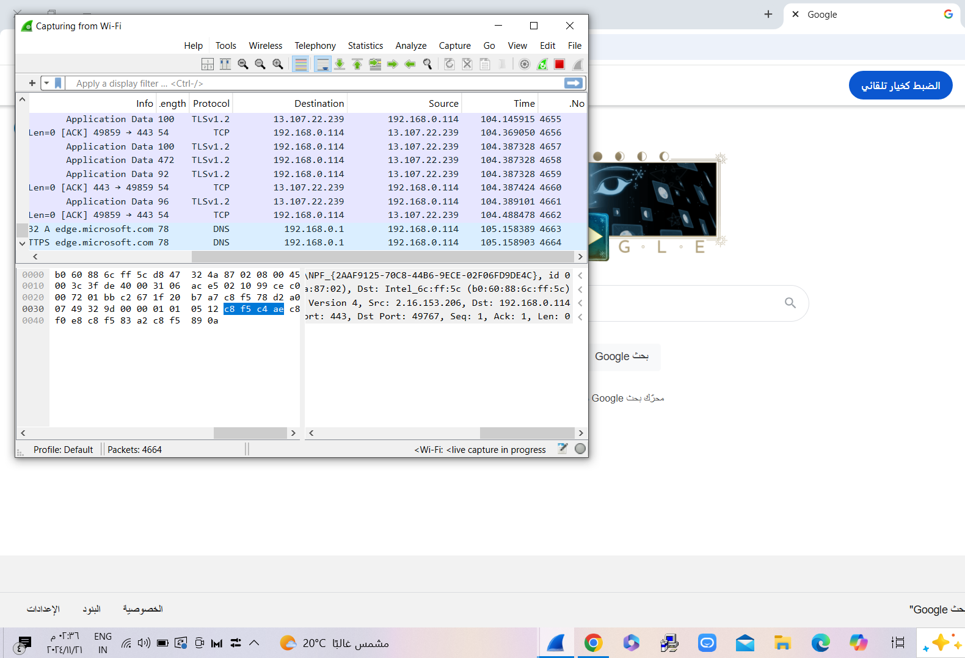figure(9) wirshark

This is a **Wireshark capture session** showing DNS traffic. A DNS query was made to resolve the hostname edge.microsoft.com (packet 32), and its response (packet 78) is visible. The capture filters only DNS packets, and the details of selected packets (protocol, source, destination, etc.) are shown in different panes. The session is still running, capturing live network traffic.

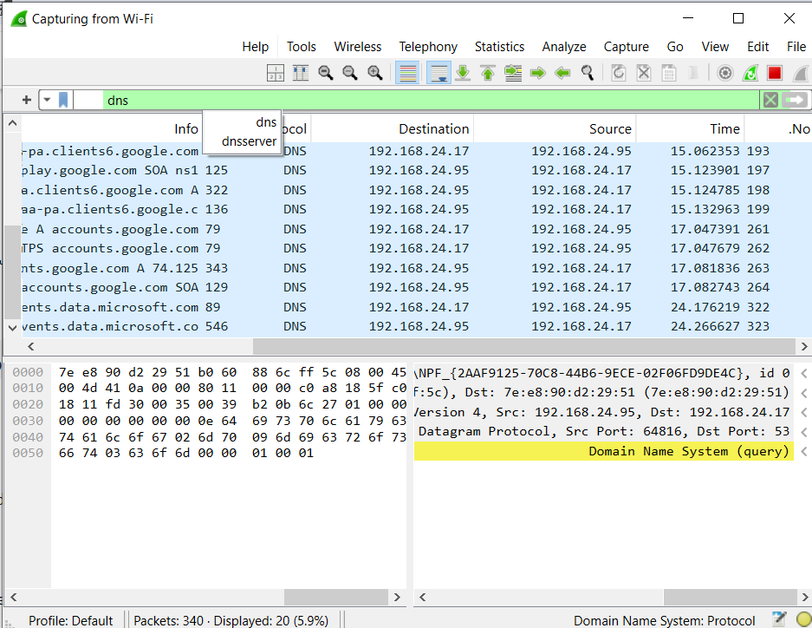figure(10) wirshark

I am used the page [www.google.com](http://www.google.com) , the name system is (query).

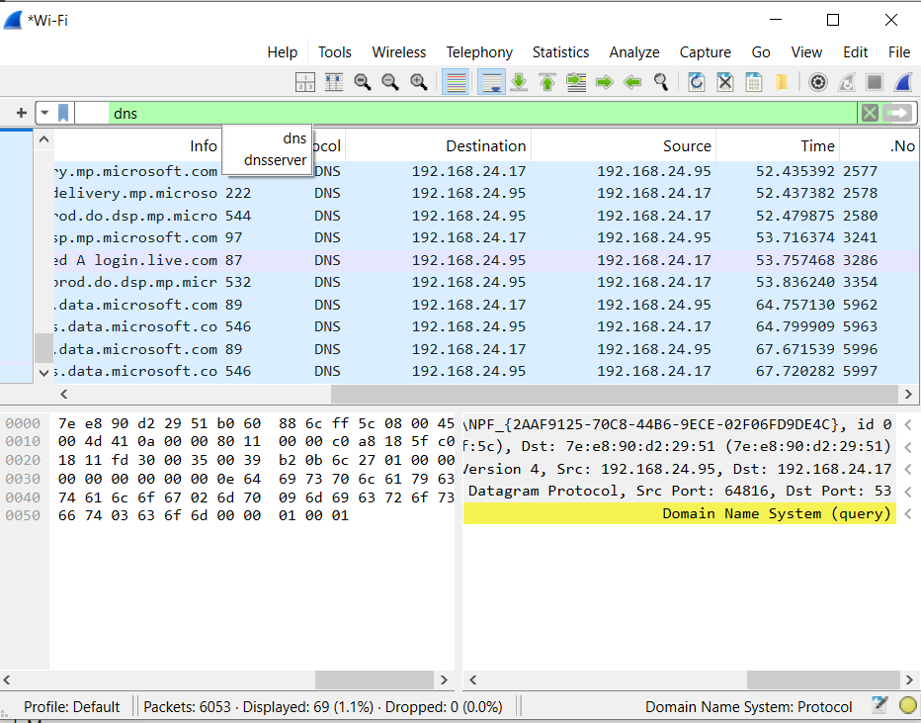figure(11) wirshark

This is a Wireshark capture session showing DNS traffic. A DNS query was made to resolve the hostname. A DNS query was made to resolve the hostname edge.microsoft.com (packet 32), and its response (packet 78) is visible. The capture filters only DNS packets, and the details of selected packets (protocol, source, destination, etc.) are shown in different panes.i am press stop , The session is stop running..

## **2. Task 2 – Web Server**

### **2.1 - Main English Webpage (main_en.html)**

The following shows our photo in this project with discuss .

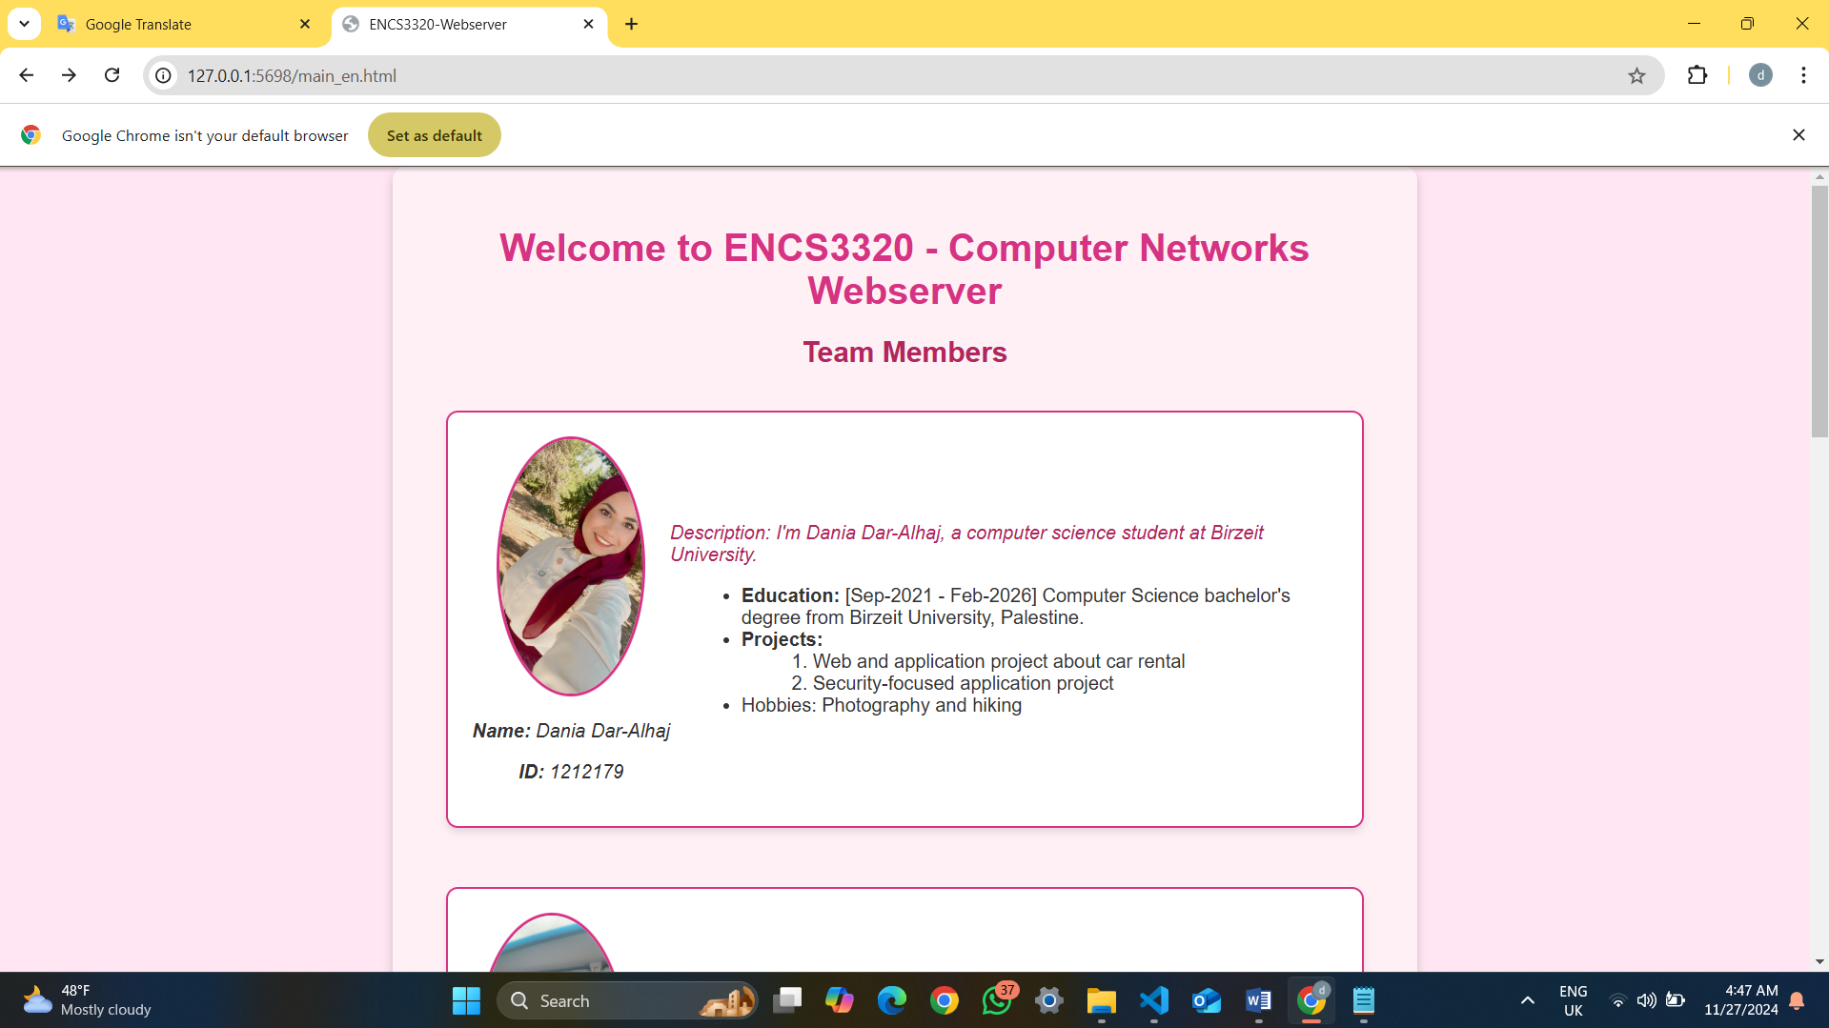figure(12) main_en.html

In this photo show The text "ENCS3320-Webserver" displayed on the web browser tab , The title "Welcome to ENCS3320 - Computer Networks Webserver" at the top of the page and the first team member Dania with id 1212179 included a photo in .png format Organize each member’s information within separate boxes contain details for education , projects and hopes . and each arranged in a table-like structure.

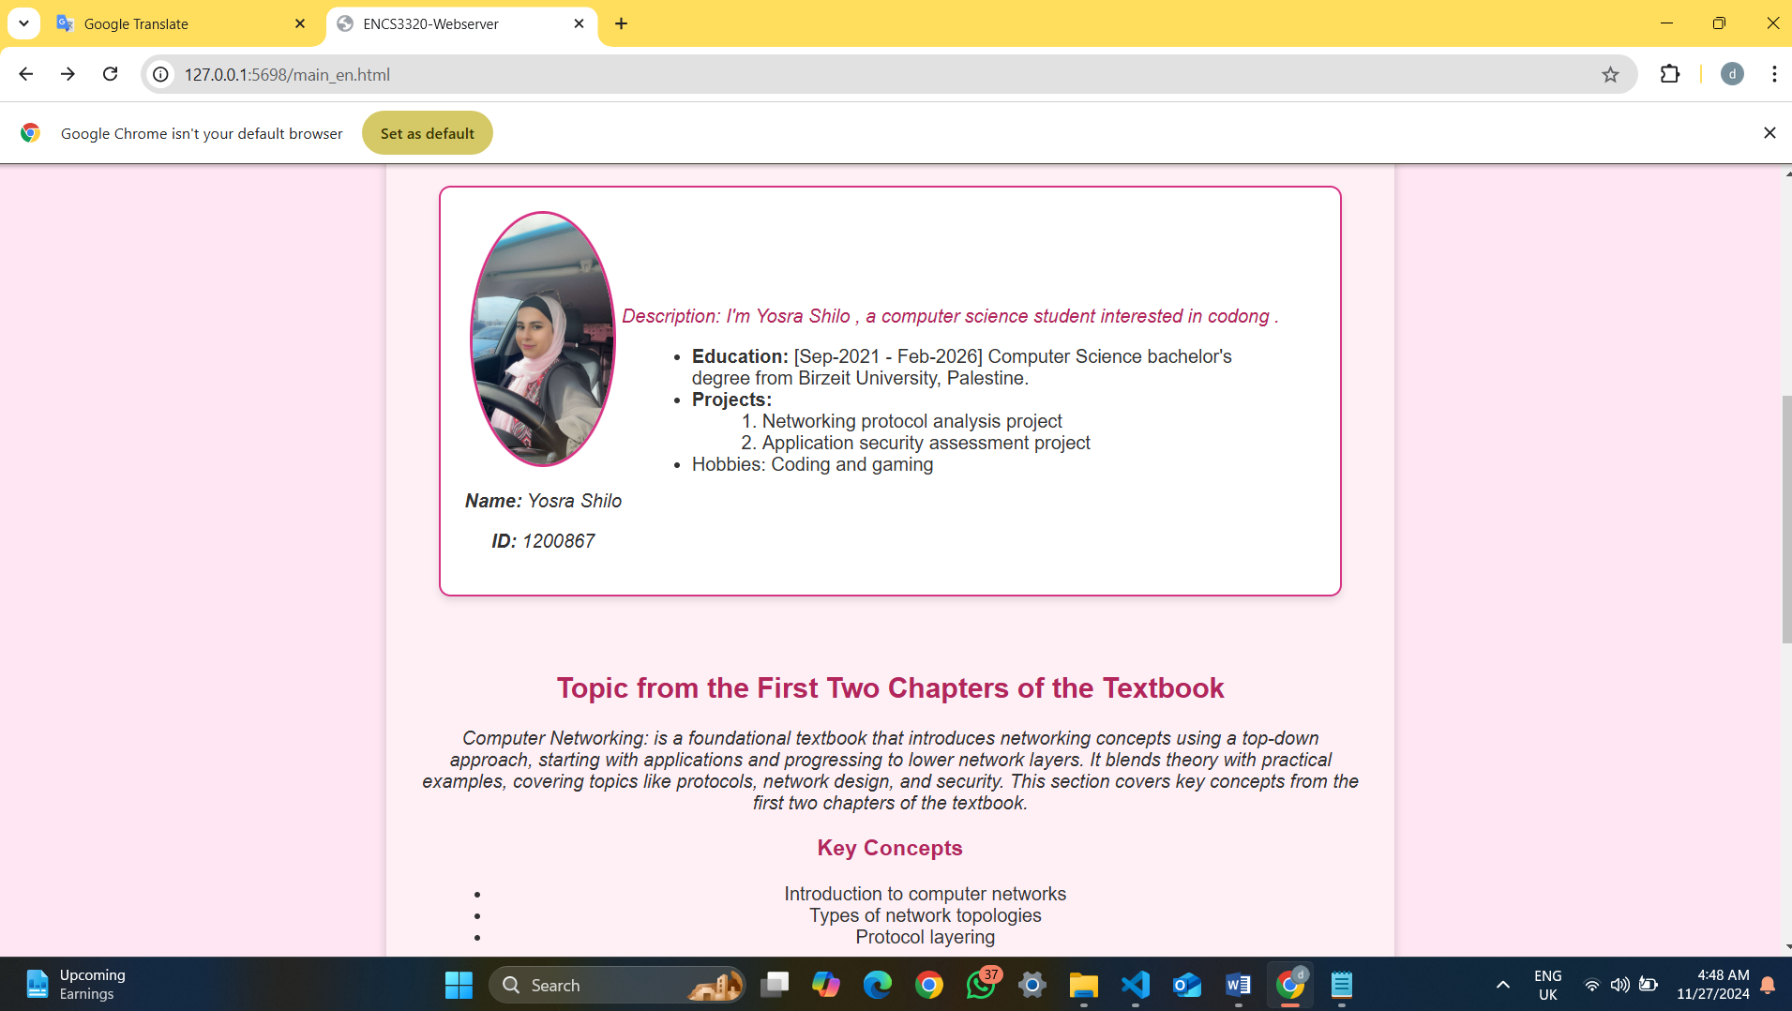 figure(13) main_en.html

The second team member Yusra with id number 1200867 , with a presented topic from the first two chapters of the textbook we show it as paragraph and its italic and key concepts as unordered list

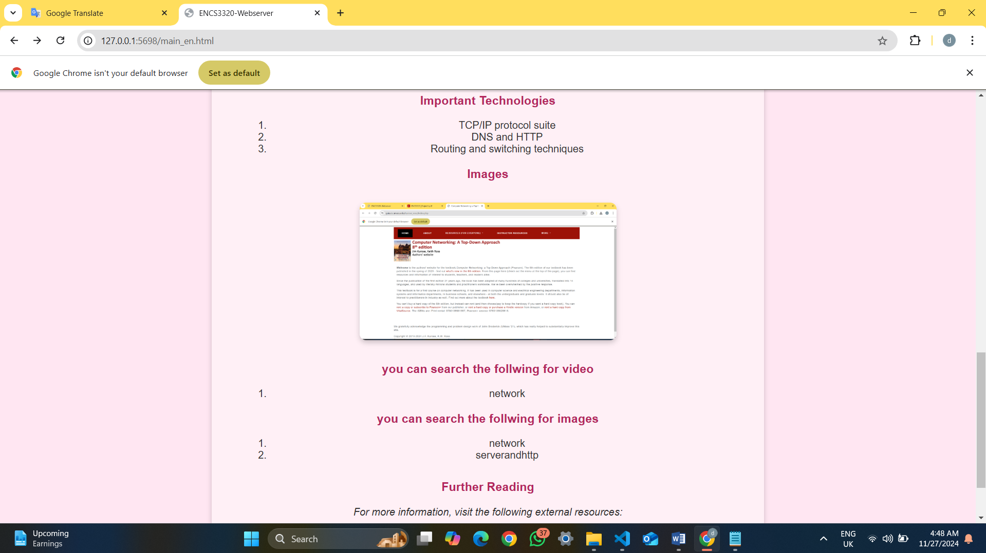 figure(14) main_en.html

And finally we included ordered list and photo for the book included images in .jpg format , and we add a links for ritaj and the text book sites and its contain what the user can search for video or images .

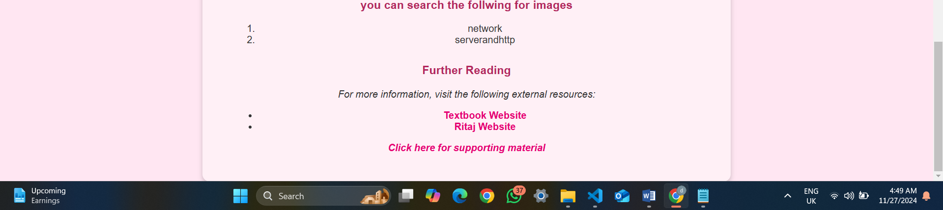figure(15) main_en.html

Hear I set 2 externa links one for text book website and the other for Ritaj website and the last line for supporting material that will redirect the user to another page for search for image or video

### **2.2 Supporting Material Page (supporting_material_en.html)**

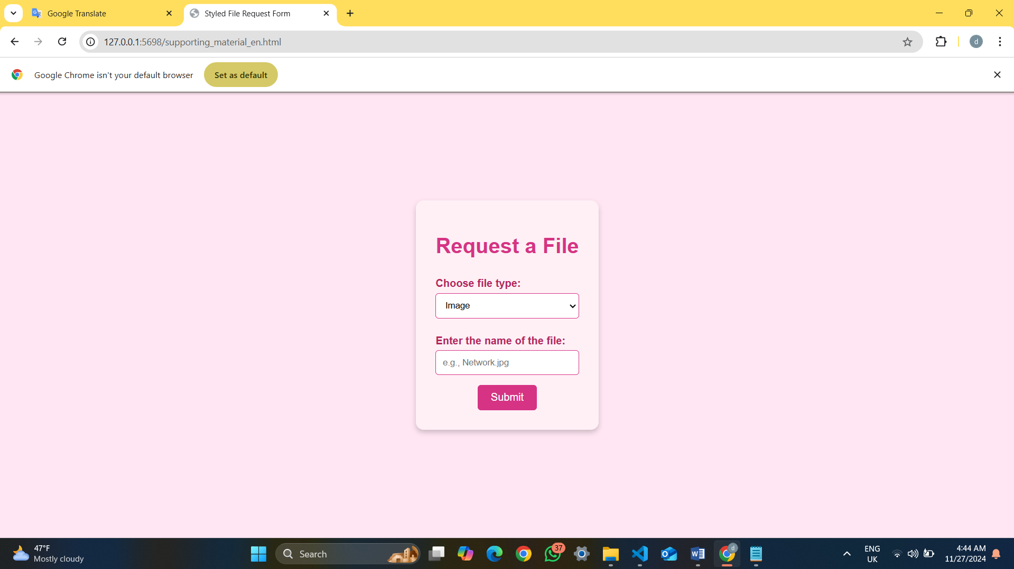figure(16) supporting_material_en.html

In supporting_material_en.html we ask the user to chose file type image or video then the name if the server find the photo or video will show it to the user , else will Redirect the user to a google search URL if it was a photo or will Redirect the user to YouTube search URL if the request is image

If the request is photo :

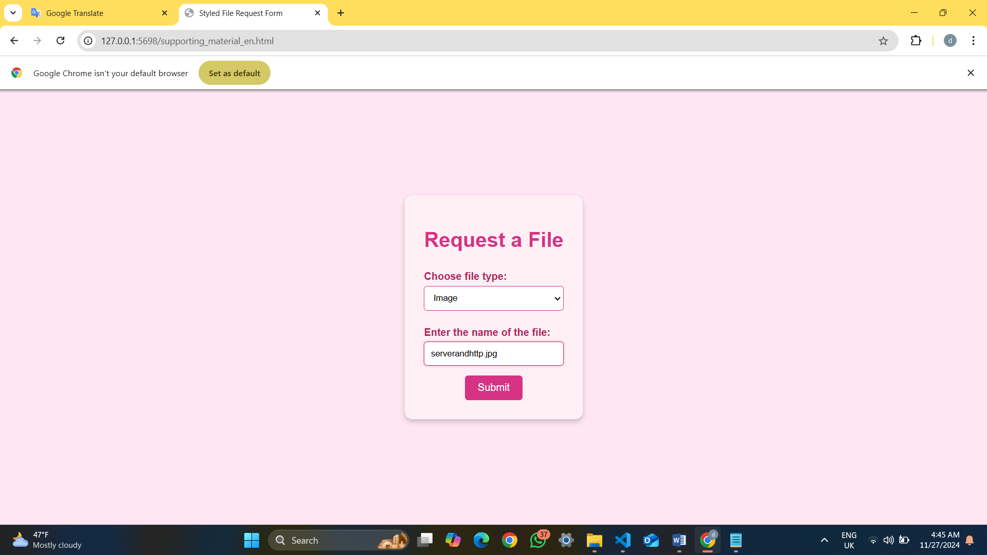figure(17) img request

Her the user search for a valid image that is its on the server and the results like the following .

**If the request is image**

If the image on the server

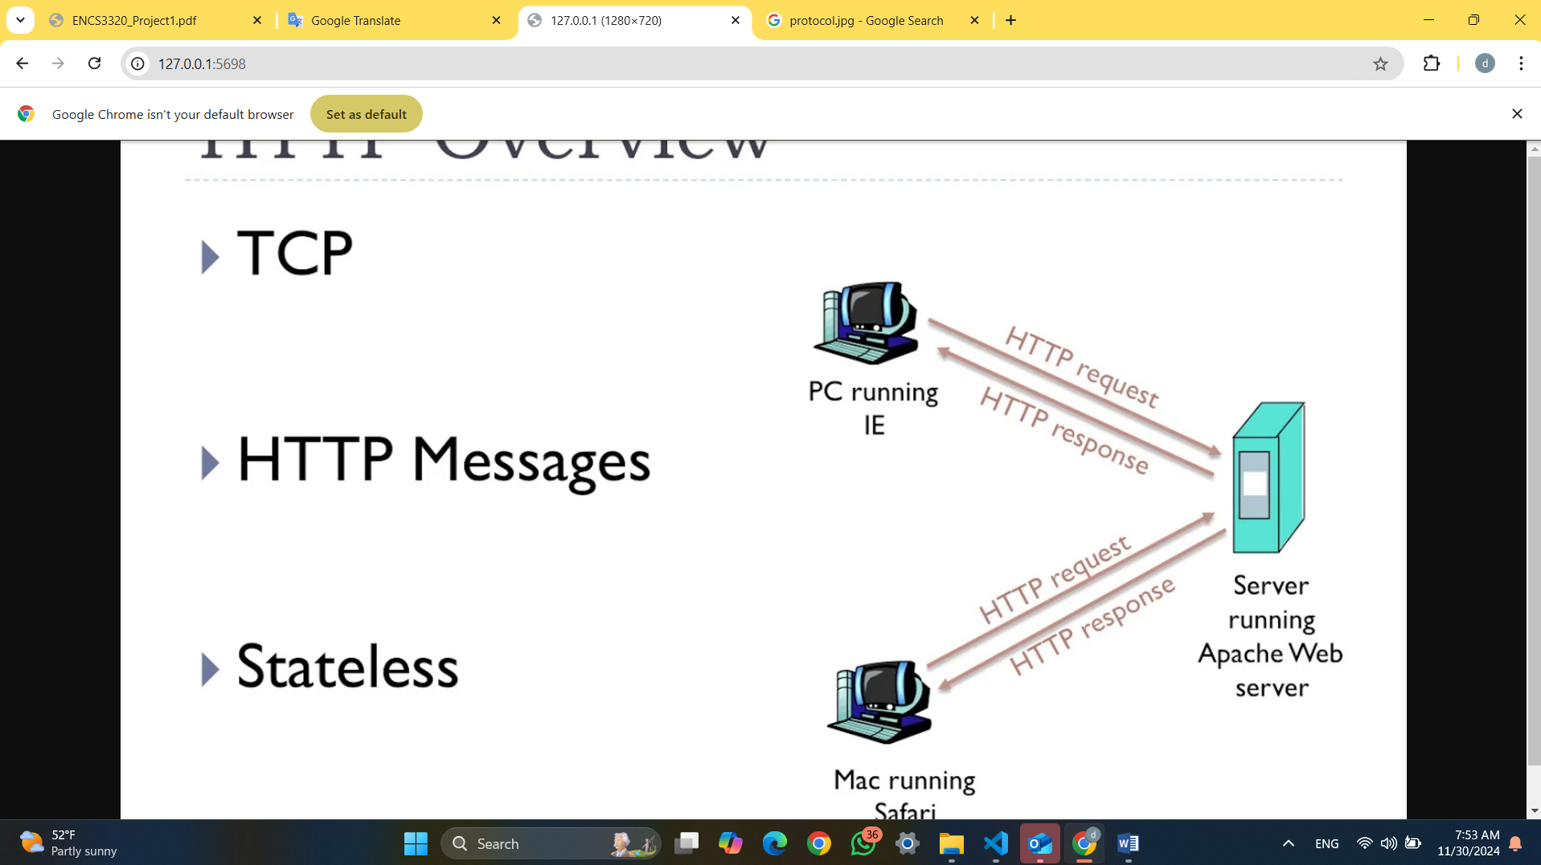 figure(18) img request results

Because image exists on the server its return the image to the user .

If the image doesn’t on the server

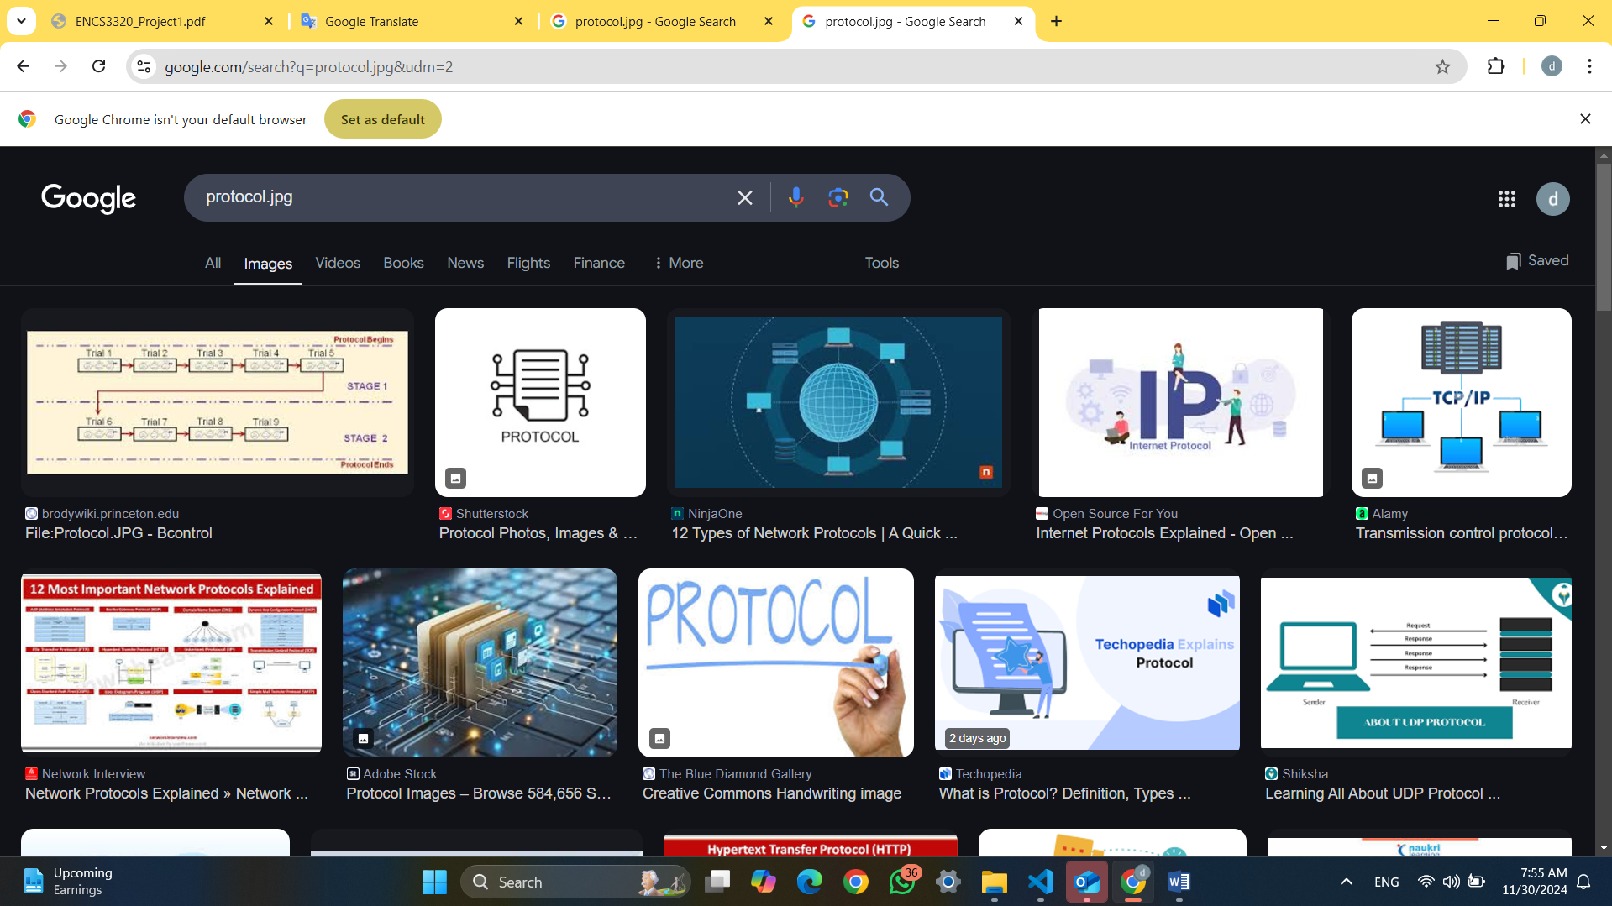figure(18) img request results

The user search for protocol which is does not find in the server so that its redirect the user by 307 Temporary Redirect .

**If the request is video**

If its does not exists 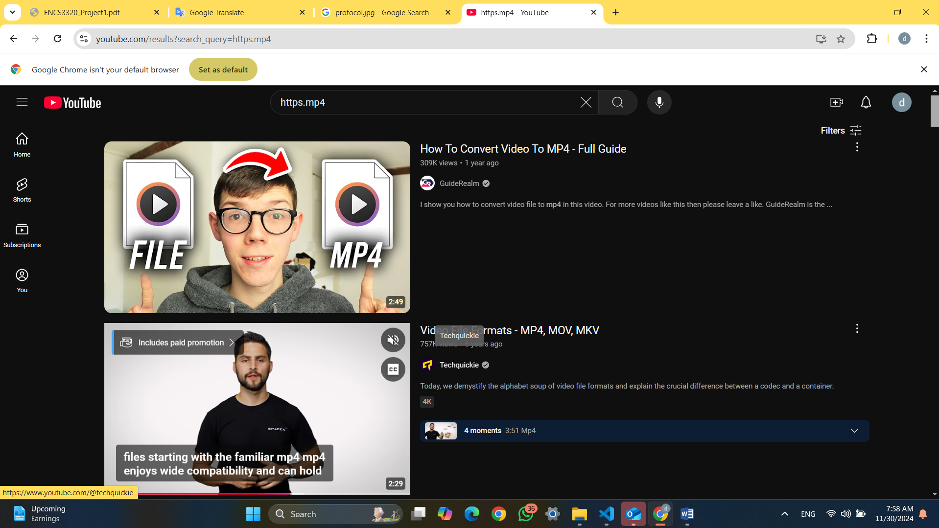 figure(19) video request results

When the user search for a video does not on the server will add the name of what his search to the URL and search for it on youtube , the user search for https so its added to the URL and search for it . its redirect it by 307 Temporary Redirect ,

If the video on the server

figure(20) video request results(2)

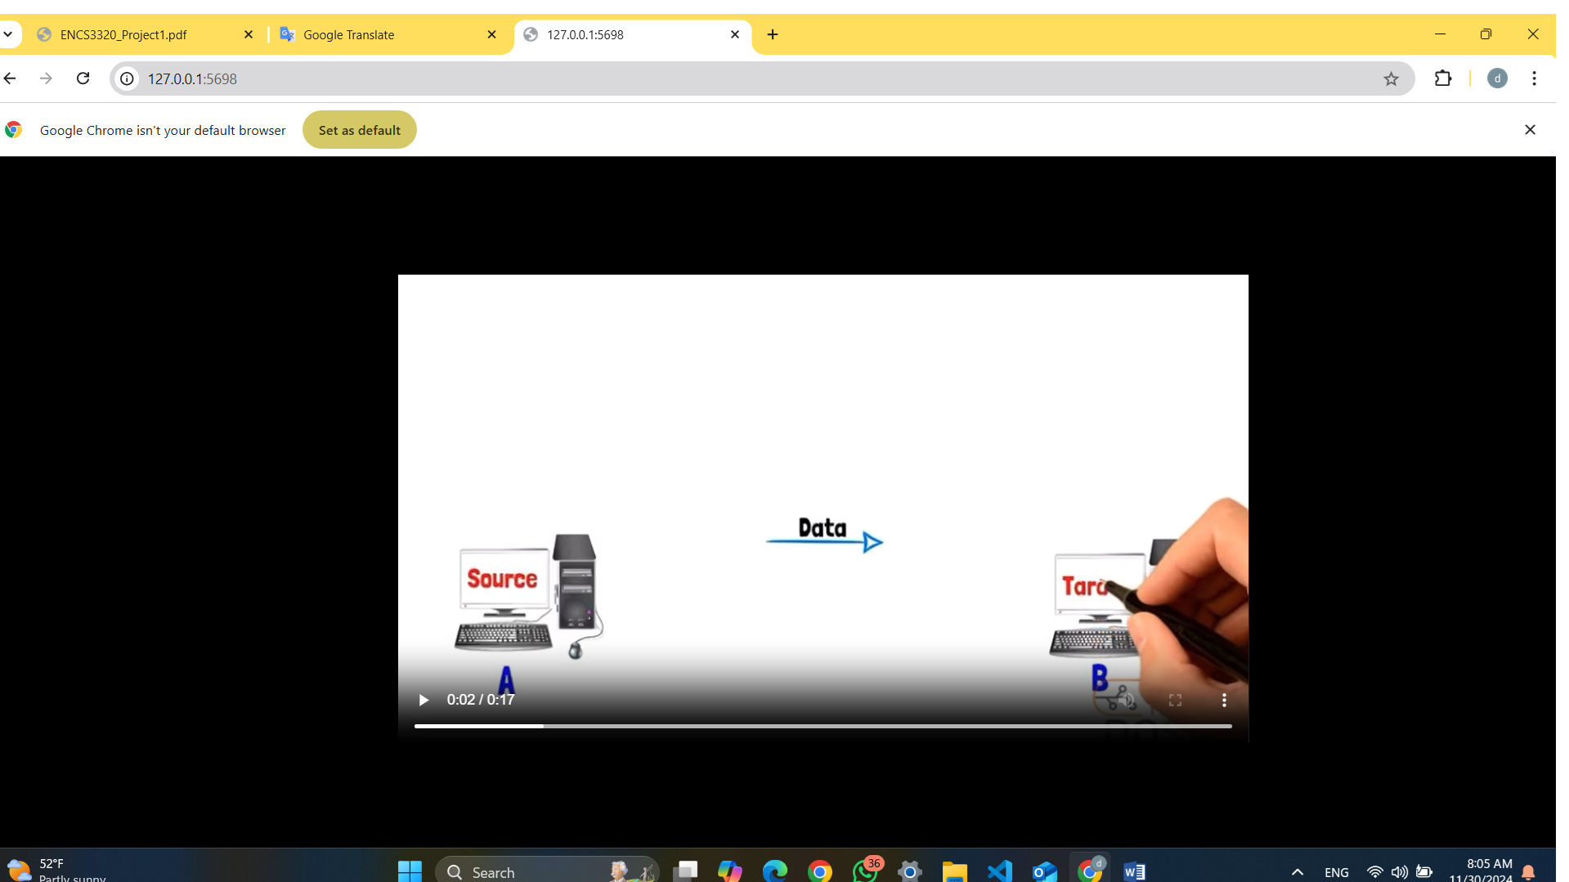

Since the video on the server will return the video to the user

### **2.3 Arabic Versions**

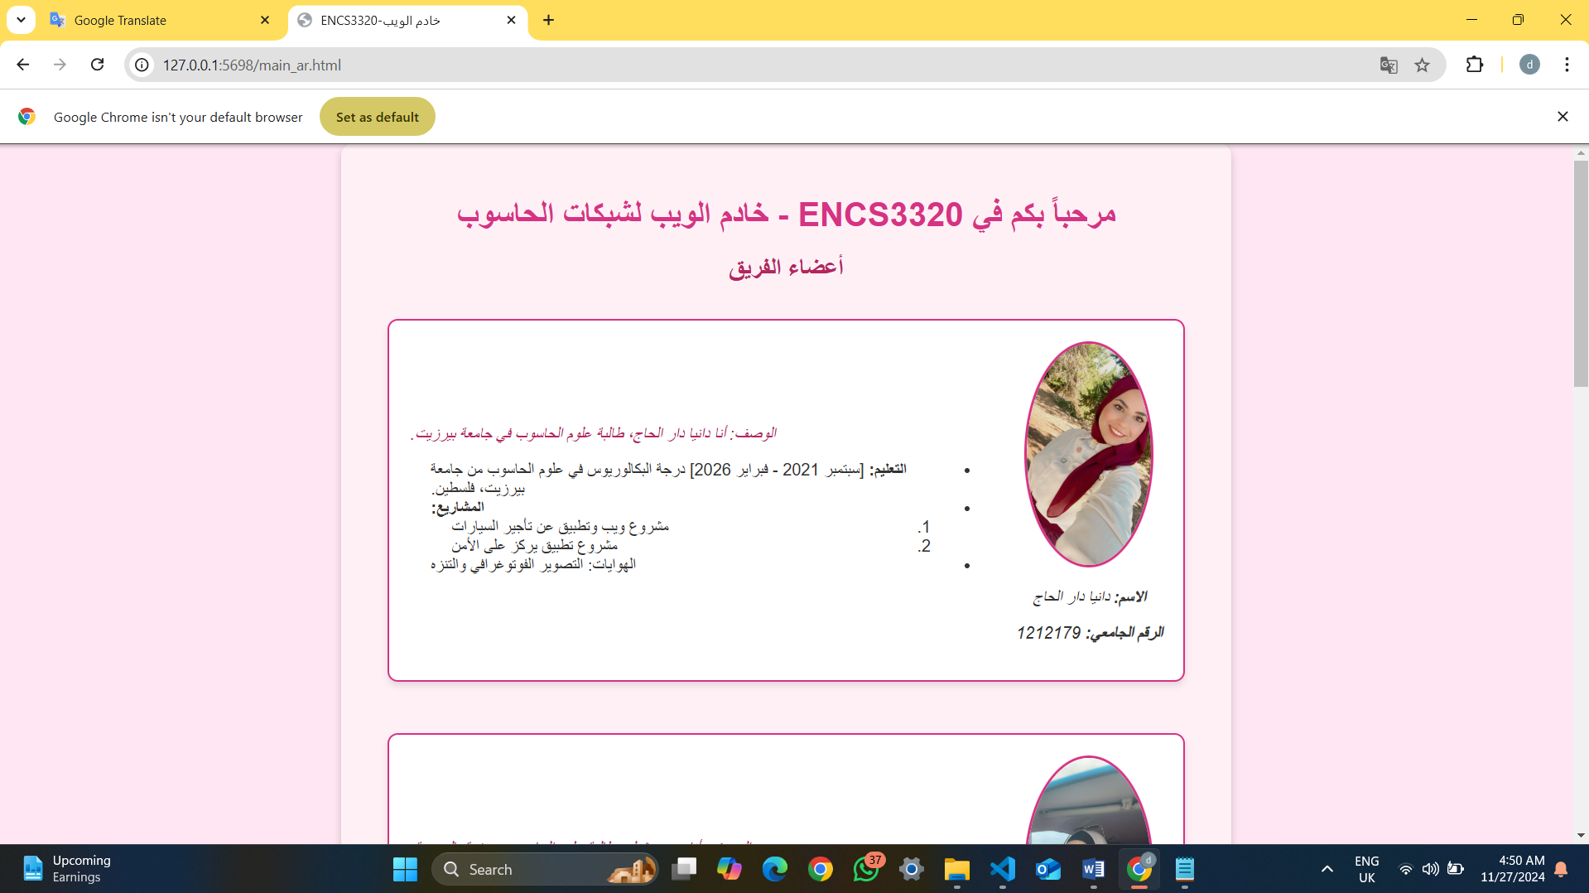figure(21) arabic version(1)

As the requirement we add an Arabic version for the site it’s the same with the above site in English , its only translated to Arabic language .

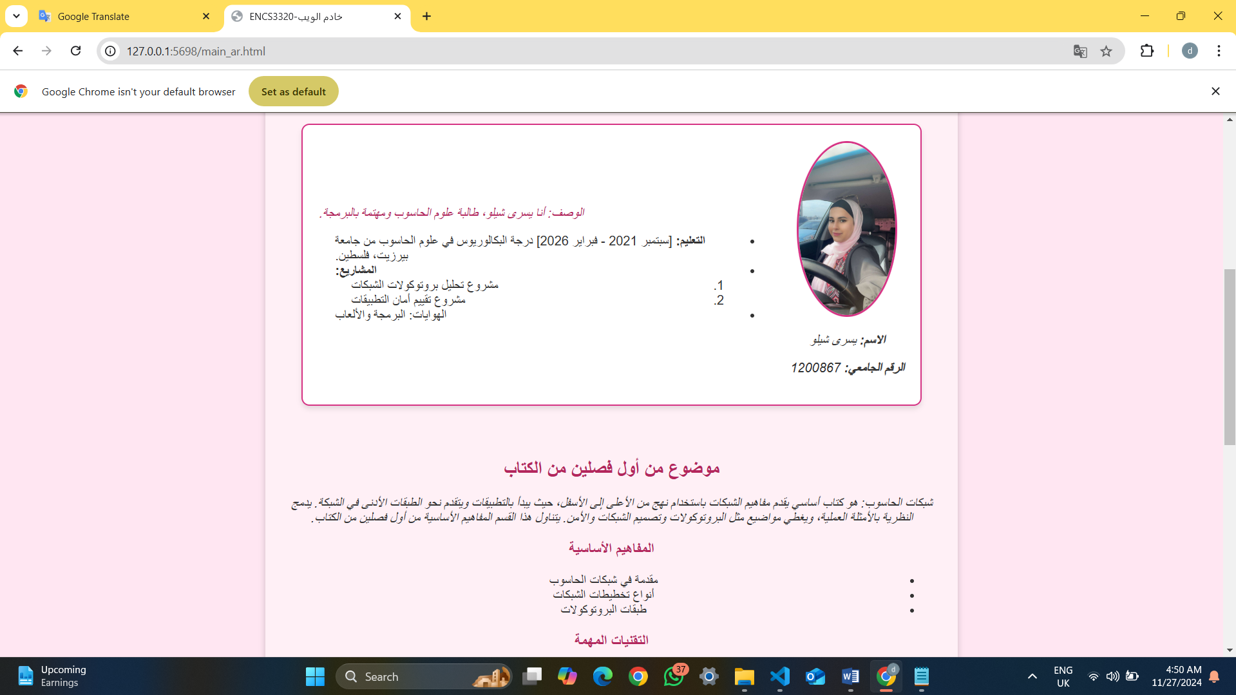figure(22) arabic version(2)

As the requirement we add an Arabic version for the site it’s the same with the above site in English , its only translated to Arabic language .

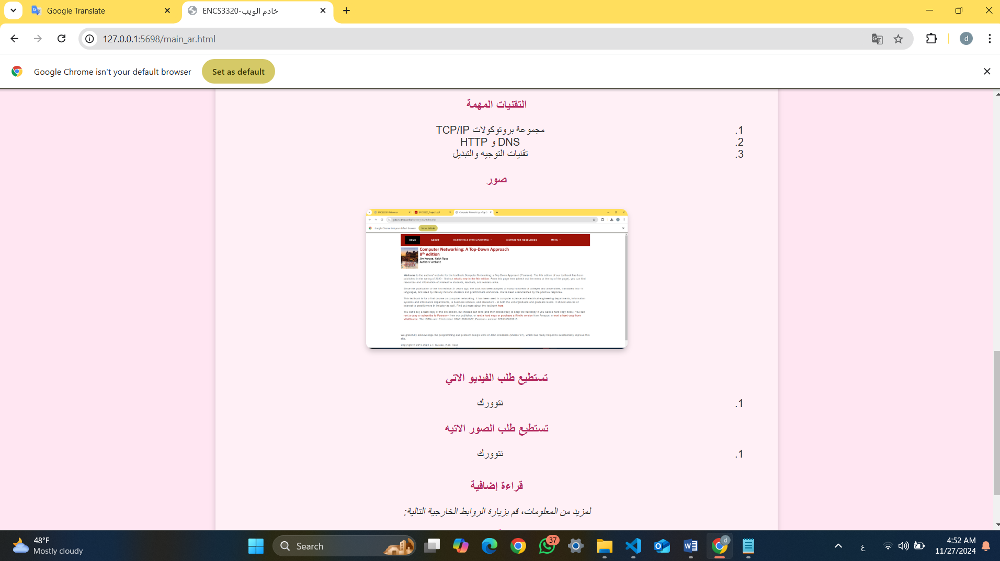 figure(23) arabic version(3)

As the requirement we add an Arabic version for the site it’s the same with the above site in English , its only translated to Arabic language .

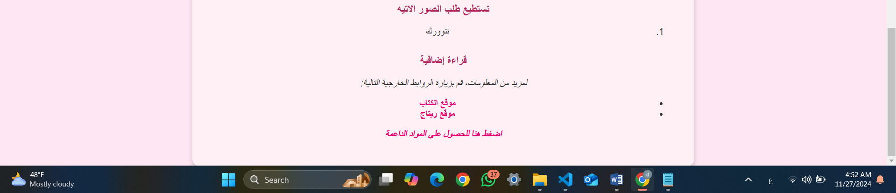 figure(24) arabic version(4)

As the requirement we add an Arabic version for the site it’s the same with the above site in English , its only translated to Arabic language .

### **Theory and Procedure for task 2**

#### 1) Explain the theoretical concepts relevant to each project requirement. Organize these ideas according to the specified titles for each section

**1. HTTP Protocol and Status Codes**

HTTP in wep is a communication protocol used for transferring data between clients, such as web browsers that transfer data between client and server . An HTTP request consists of three main parts: the request line , headers , and body . The request line specifies the HTTP method (GET or POST), the requested path, and the HTTP version such as http/1.1 . Headers provide essential metadata about the request, such as the Content-Type indicating the format of the data and Content-Length specifying the size of the body. The body is included only in methods like POST` and contains the data being sent to the server ..

Servers respond with three HTTP status codes that i handled in my case with working with wep that each one is indicate the result of the request **: 200 OK status** signifies a successful request , in my case its the status for all successful request**. The 307 Temporary Redirect** code informs the client to redirect to another URL while maintaining the original request method that if the request is get will still get and if its post will stil post , its a way that i use it to redirect the client to another request that if the client order photo or video not on the server the http request the status will be 307 Temporary then i redirect the client to another URL according to the request**. 404 Not Found code** indicates that the requested resource is unavailable, and 415 Unsupported Media Type is returned when the server cannot process the request due to an unsupported file format. and in my case the status was 404 when get a wrong http request or anything that i cant manage it because its a wrong request 404 will happen

**2. File Handling and Content Types**

The server retrieves files from a specified directory and determines their existence before sending the response. If the file exists, it's read in binary mode (rb) that is the binary mode is Binary mode refers to a method of handling files in their raw, unprocessed form, without any interpretation or conversion of the data. When a file is opened in binary mode (using 'rb' for reading or 'wb' for writing), the file's contents are treated as a sequence of bytes. This is essential for non-text files like images, videos, audio files, and executable programs, where even small modifications can corrupt the file. , and the appropriate content type is determined based on the file extension. that is HTML: text/html , CSS: text/css, Images: image/png, image/jpeg , Videos: video/mp4 , Default: application/octet-stream .

**3. Redirection Logic Based on File Type**

Handling Images and Videos , If the requested file is unavailable Images: Redirects to Google Image Search with a query parameter that i used https://www.google.com/search?q=file_name&udm=2 to redirect the user to a photos on google according client research . Videos: Redirects to YouTube Video Search on the following request <https://www.youtube.com/results?search_query=file_name>

2 ) explanation and images with description and flow char

First I will show the request for the website as a flowcharts to understand .

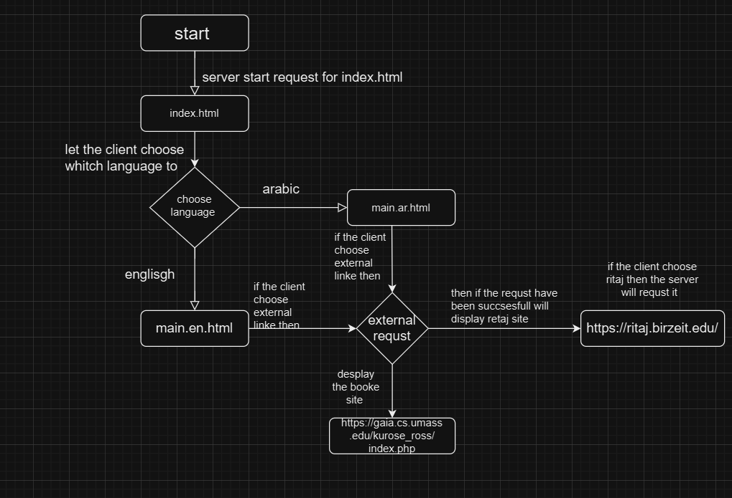figure(1) flowchart

This part of flowchart show us the step and the http request that we have it in this task that the first its order the index.html that will allow the client to request Arabic or English language then if the user asked Arabic languge then the server request main.ar.html and if the user ordered English will request the page main.en.html then the client can order external resource such as if its orderd ritaj the server will request ritaj page and if the client order thebook text the server order the book site and theuser can order supporting_material_ar.html or supporting_material_en.html but I will explain it latter .

### **2.2.4 Server Functionality**

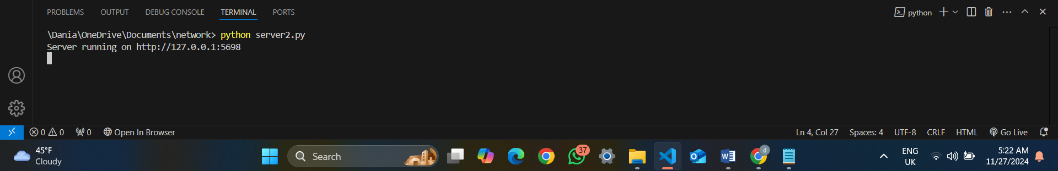figure(25) run server

When run the server direct will connect to the i run server2.py that starts a server on my local device on (http://127.0.0.1:5698) . The server is now running and ready to handle the requests on port 5698 .

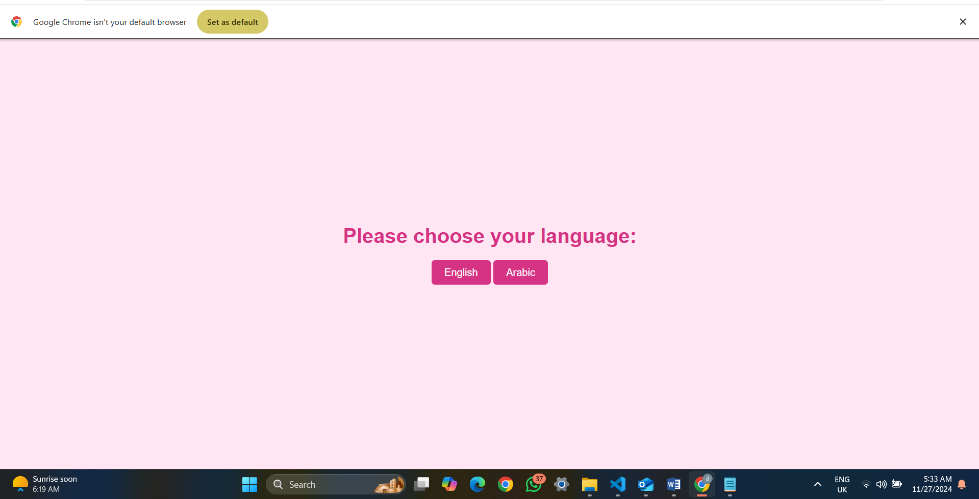figure(26) index.html page

I creat this page to allow the user to choose his language Arabic or English which is connected with the server . once the user choose Arabic language will directly go to supporting_material_ar.html page and if the user choose supporting_material_en .html will directly go to the English language page.

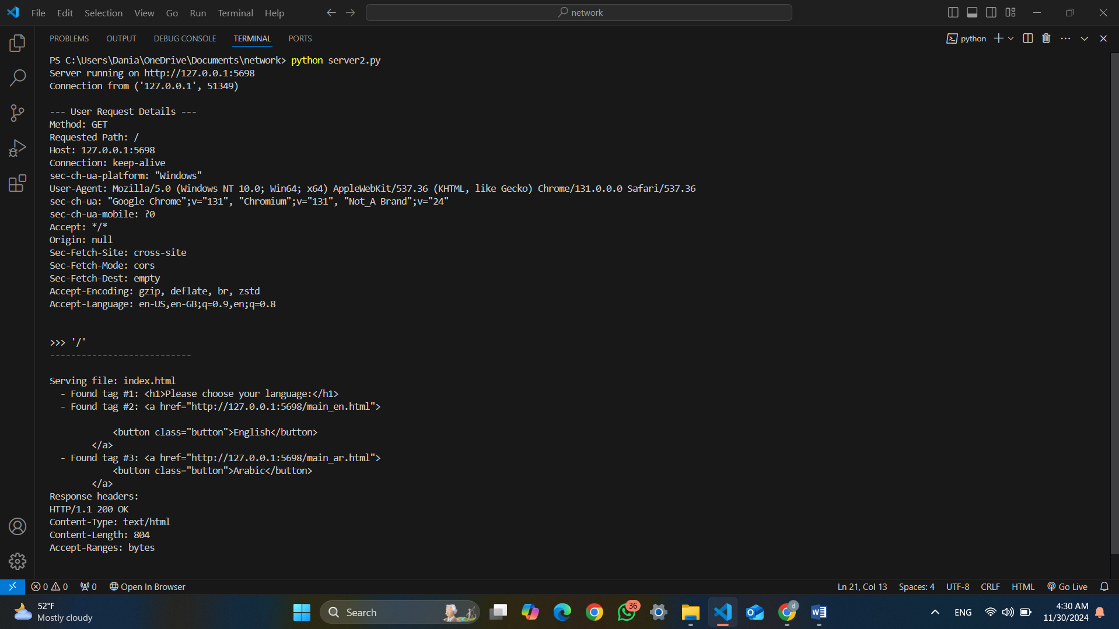 figure(26) run page

Now when I enter to the index.html page by the browser I get this results , its print the following Method: GET , its mean I entered to the page by get method with a Host: 127.0.0.1:5698 , Connection: keep-alive that the connection I still alive , **Path**: / it mean it’s the root page as User-Agent: Mozilla/5.0 (Windows NT 10.0; Win64; x64) AppleWebKit/537.36 (KHTML, like Gecko) Chrome/131.0.0.0 Safari/537.36 it’s mean that I entreated with widows operating system and sec-ch-ua: "Google Chrome";v="131", "Chromium";v="131", "Not_A Brand";v="24" its mean thati entered with googl chroom . Serving file: index.html the name of the file that I entered as its print the h1 details (Found <h1>: Please choose your language ) .

Then its print the details for the index.html that is print h1 then the anchor (a) print \http://127.0.0.1:5698/main_en.html that is will redirect the client to English page on this http request for main_en page and the same for Arabic

### As its print more detais about Response headers:

### HTTP/1.1 200 OK that is its mean we user HTTP 1.1 and the request was successful . Content-Type: text/html the content of the file is an HTML document.

### Content-Length: 804 it tells the browser that the HTML file being sent has a size of 804 bytes .

Finally I want to explain the links that when click to Arabic language will redirect the user into the <http://127.0.0.1:5698/main_en.html> if the user asked English language , this linke mean The client (browser) sends an HTTP request to the server (HTTP) , 127.0.0.1 It means that the request is being sent to a web server running on the same machine and , :5698 server is running on **port** 5698

**Now I will entered to the English page**

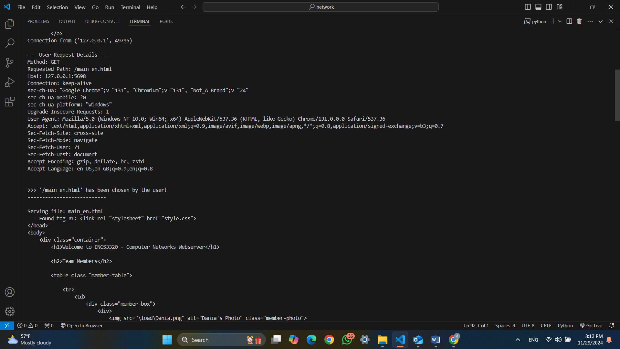 figure(27) run main_en.html page

Its print first the connection details that I entered by Google Chrome with , windows operating system , method get with a host 127.0.0.1:5698 and with the main_en.html .. with some another details such as I don’t entered by phone so that it’s a question mark … , after that its print the details for request everything for html and tags and details in order what its found . after that the client browser sends an HTTP GET request to the server asking for the main_ar.html file after chose arabic language then The server reads the main_ar.html file from its directory.As the file is read line by line, the server starts parsing the HTML structure to generate a response. the server read line by line in the html and print it on the terminal as its happened in the browser to revew it to the clint

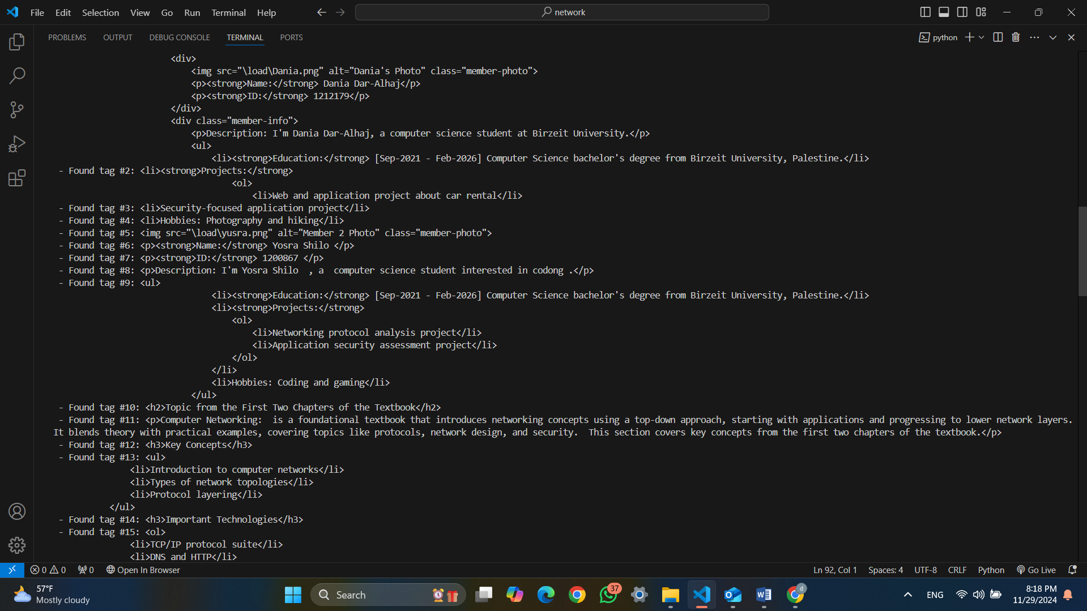figure(28) run main_en.html page

The server still prints each important tag as it processes the file in sequanse about how its find each element in the html and print it on the terminal

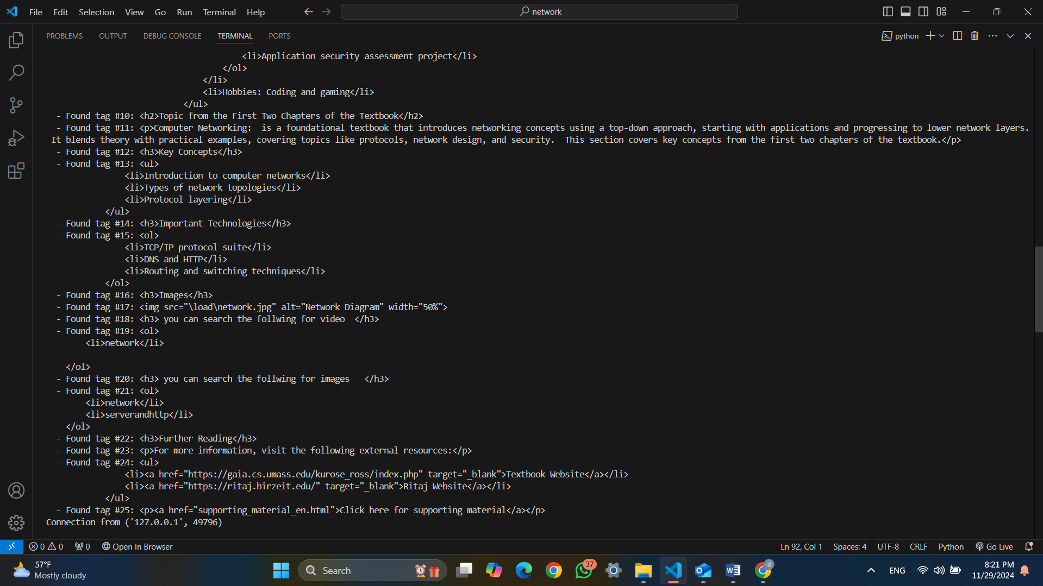figure(29) run main_en.html page

The server still prints each important tag as it processes the file in sequence about how its find each element in the html and print it on the terminal

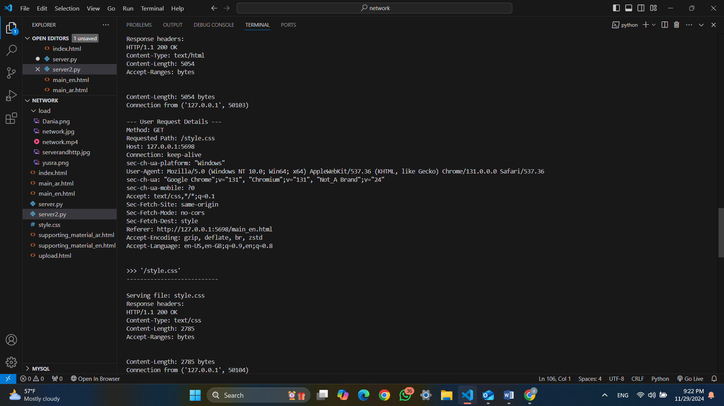 figure(30) run main_en.html page (2)

Now will print the details of the page about the contains , ordered images and how its ordered … , First Request is text/html that its ordered html page HTTP/1.1 200 OK indicates that the request was successful as the length size is 5054 . the secound request was for CSS file (/style.css) , by method: GET and the Requested Path is /style.css so its requested the CSS file style.css from the server as the HTTP/1.1 200 OK that is its mean we user HTTP 1.1 and the request was successful . Content-Type: text/html the content of the file is an HTML document and the Content-Length is 2785.

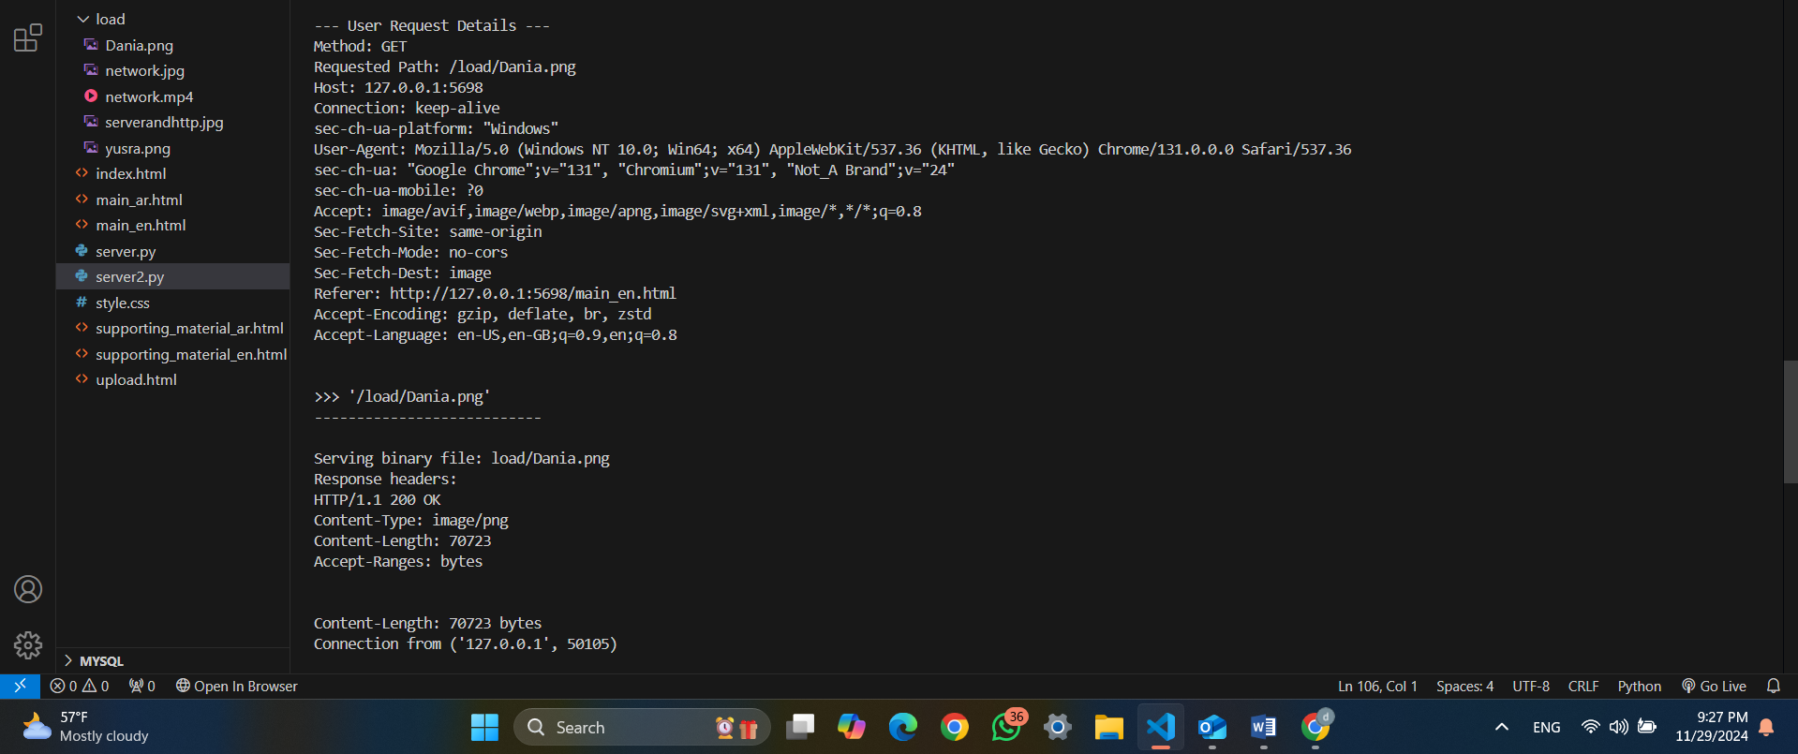

figure(31) run main_en.html page (2)

the server ordered the image on the server (/load/Dania.png) by Method: GET , Requested Path: /load/Dania.png , The server is successfully serving binary files (like images) by reading them in binary mode (Images like .png, .jpg, and are stored in binary format. Binary mode ensures that all bytes in the file are transferred **exactly as they are**, without any modification so that I used binary mode) and sending them to the client with the correct Content-Type. As its print more details asuch as the Content-Type is image/png that its ordered html page HTTP/1.1 200 OK indicates that the request was successful as the length size is 70723

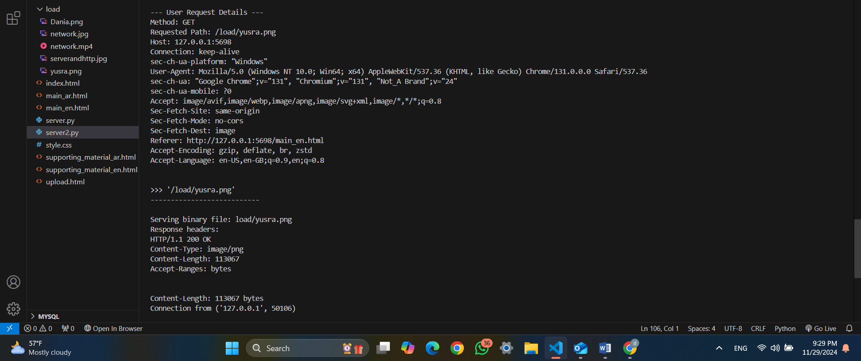 figure(32) run main_en.html page (2)

Request is Image , the server ordered the image on the server (/load/Yusra.png) by Method: GET , Requested Path: /load/ Yusra.png , The server is successfully serving binary files (like images) by reading them in binary mode and sending them to the client with the correct Content-Type. As its print more details asuch as the Content-Type is image/png that its ordered html page HTTP/1.1 200 OK indicates that the request was successful as the length size is 113067

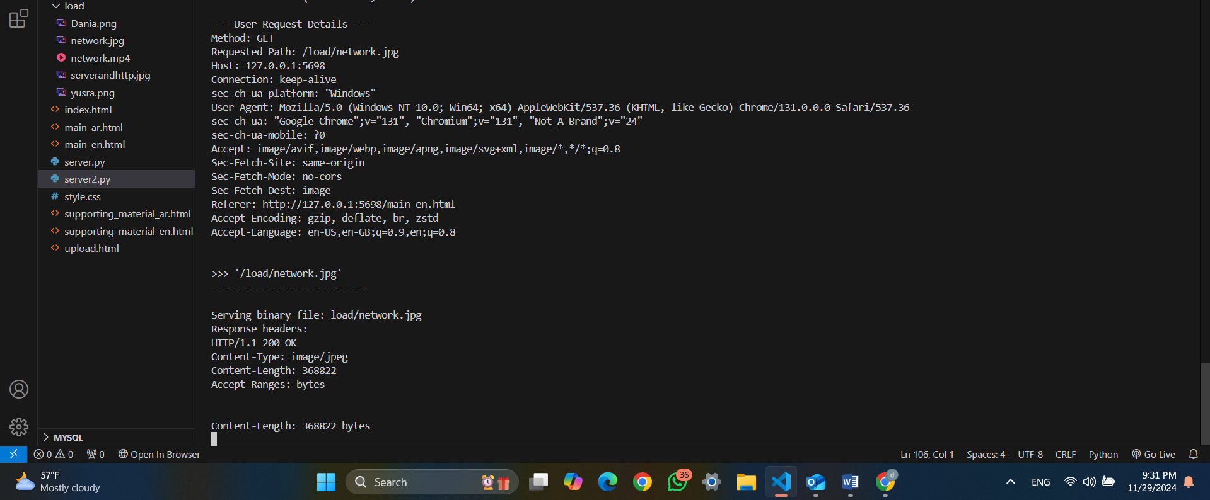figure(33) run main_en.html page (2)

Request is Image , the server ordered the image on the server (load/network.jpg) by Method: GET , Requested Path: load/network.jpg, The server is successfully serving binary files (like images) by reading them in binary mode and sending them to the client with the correct Content-Type. As its print more details asuch as the Content-Type is image/jpeg that its ordered html page HTTP/1.1 200 OK indicates that the request was successful as the length size is 368822

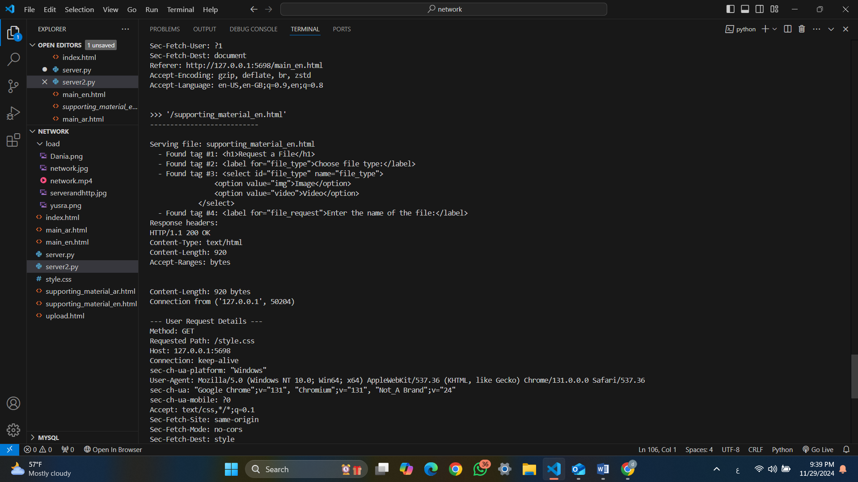figure(34) run main_en.html page (2)

Now I order supporting_material_en.html page first print the content of the html then give me more details about the request . The request was successful, and the file was served without any issues page HTTP/1.1 200 OK indicates that the request was successful as the length size is 920 and the Content-Type is text/html . the server fetch the CSS file (style.css) to style the HTML page

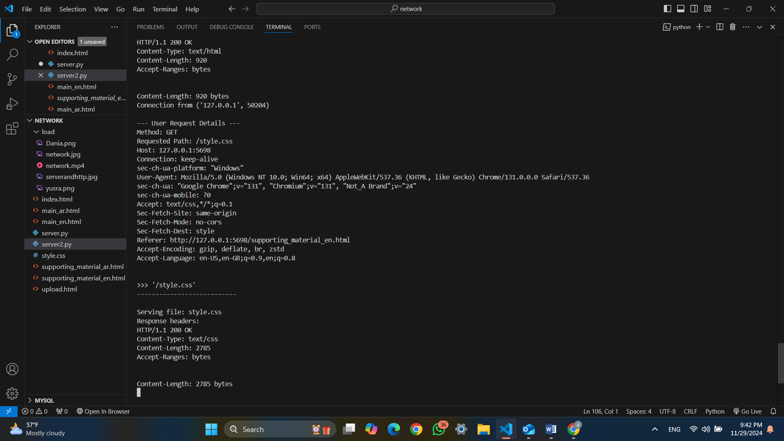figure(35) run main_en.html page (2)

Hear the server order style.css for supporting_material_en page . that its receive GET request for the file /style.css which was found and served by the server . The request came from a client running on a Windows platform .

**When choose Arabic language will interact with main_ar.html page**

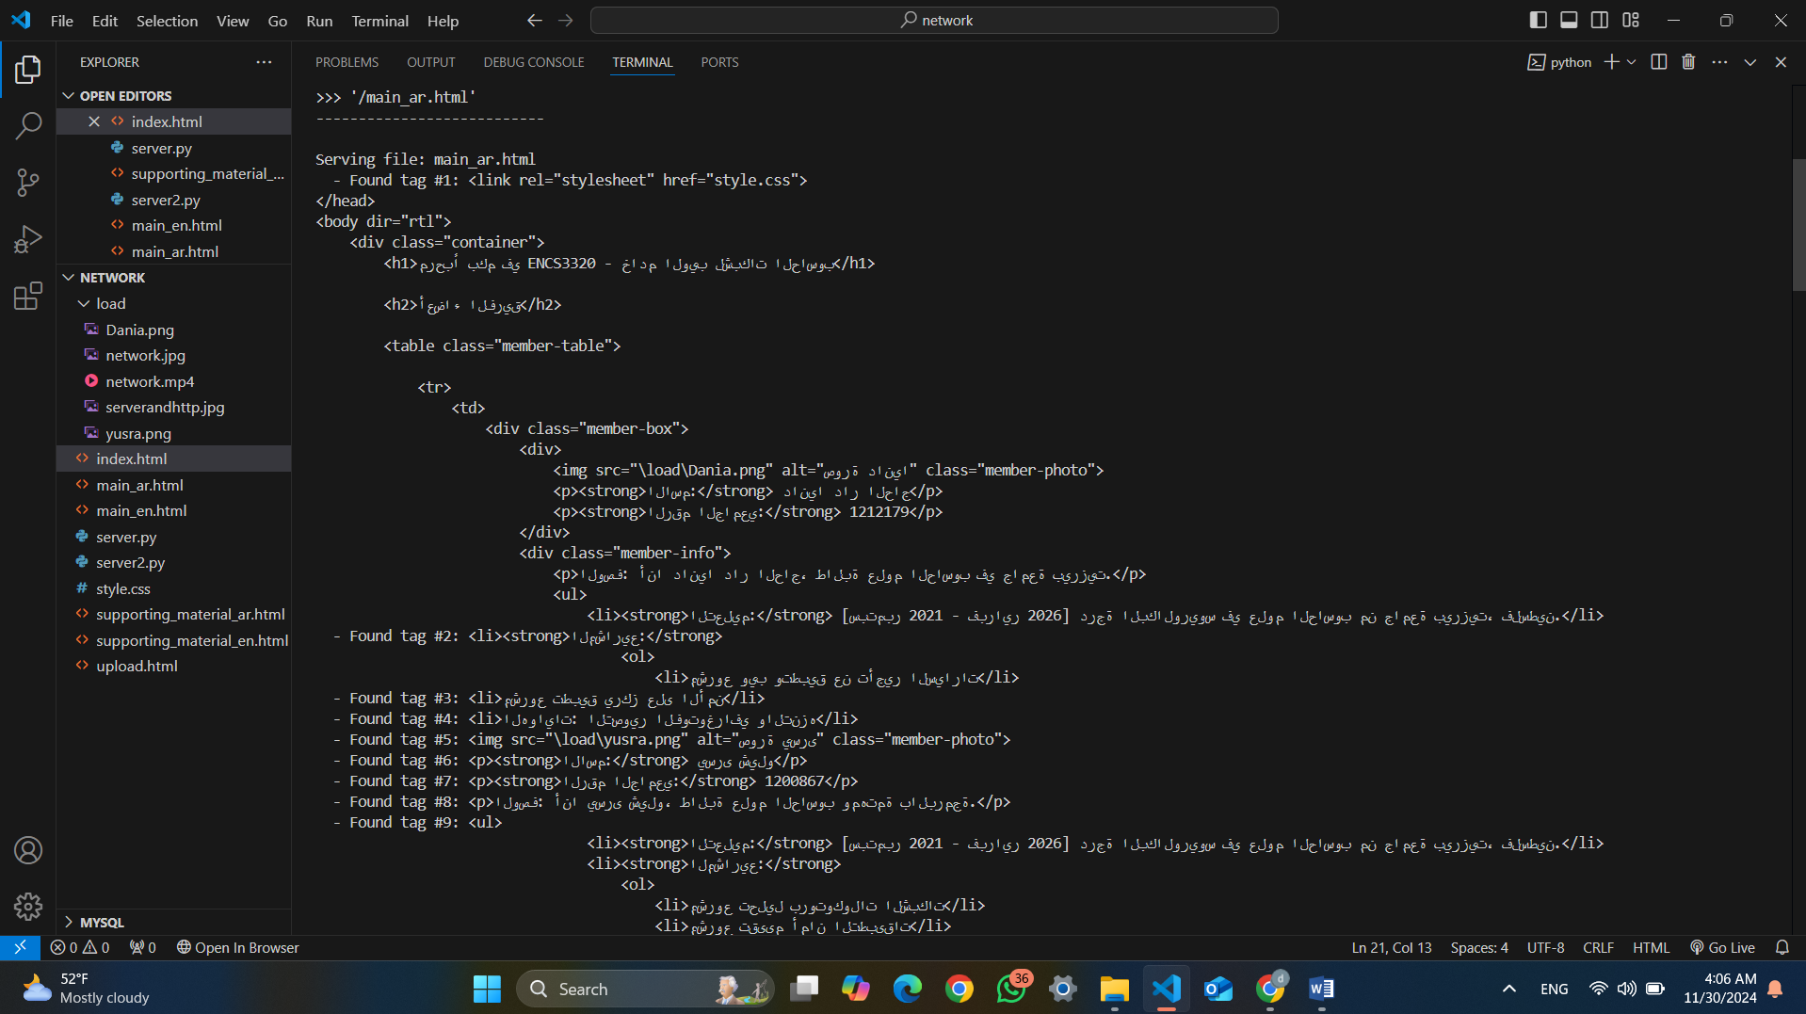figure(36) run main_ar.html page (1)

after that the client browser ordered the Arabic language then the server sends an HTTP GET request to the server asking for the main_ar.html file then The server reads the main_ar.html file from its directory . As the file is read line by line, the server starts parsing the HTML structure to generate a response. the server read line by line in the html and print it on the terminal as its happened in the browser to review it to the client .

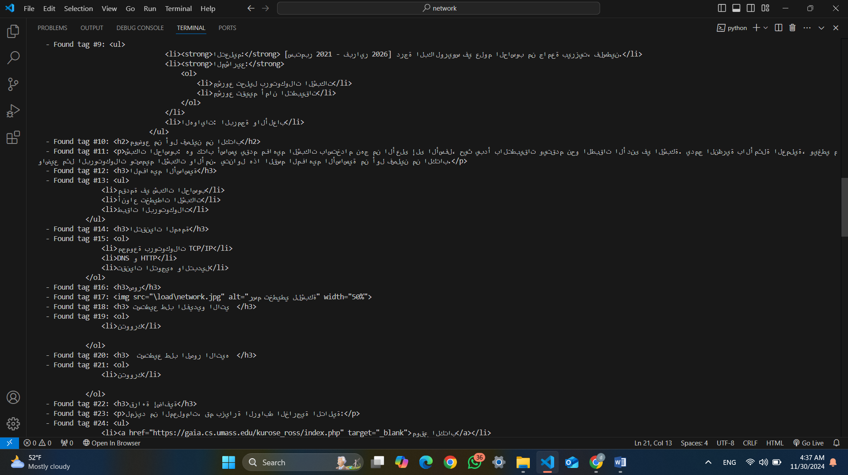figure(37) run main_ar.html page (1)

The server still prints each important tag as it processes the file in sequence about how its find each element in the html and print it on the terminal

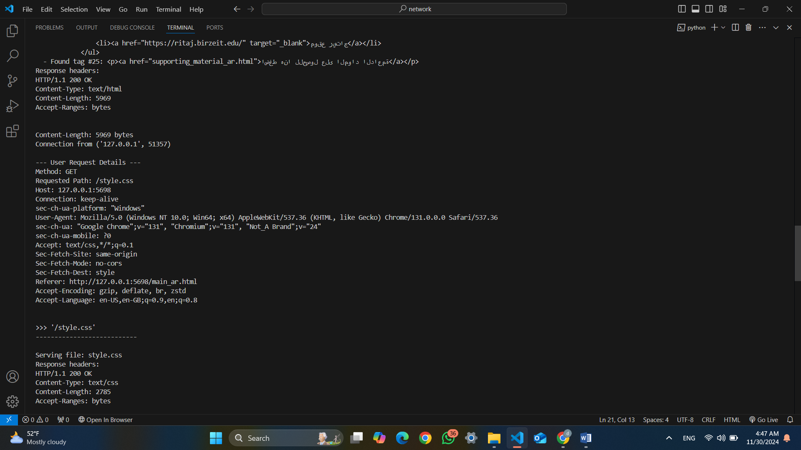figure(38) run main_ar.html page (1)

Now will print the details of the page about the contains , ordered images and how its ordered … , First Request is text/html that its ordered html page HTTP/1.1 200 OK indicates that the request was successful as the length size is 5969. the secoun request was for CSS file (/style.css) , by method: GET and the Requested Path is /style.css so its requested the CSS file style.css from the server as the HTTP/1.1 200 OK that is its mean we user HTTP 1.1 and the request was successful . Content-Type: text/html the content of the file is an HTML document and the Content-Length is 2785.

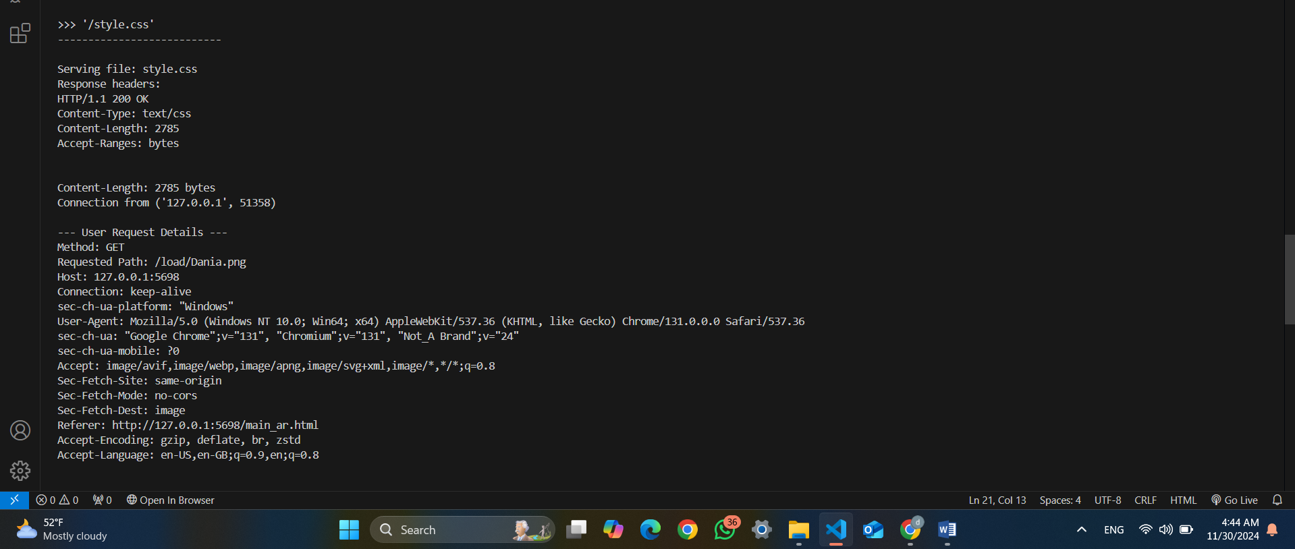 figure(39) run main_ar.html page (1)

the server ordered the image on the server (/load/Dania.png) by Method: GET , Requested Path: /load/Dania.png , The server is successfully serving binary files (like images) by reading them in binary mode (Images like .png, .jpg, and are stored in binary format. Binary mode ensures that all bytes in the file are transferred **exactly as they are**, without any modification so that I used binary mode) and sending them to the client with the correct Content-Type. As its print more details asuch as the Content-Type is image/png that its ordered html page HTTP/1.1 200 OK indicates that the request was successful as the length size is 70723

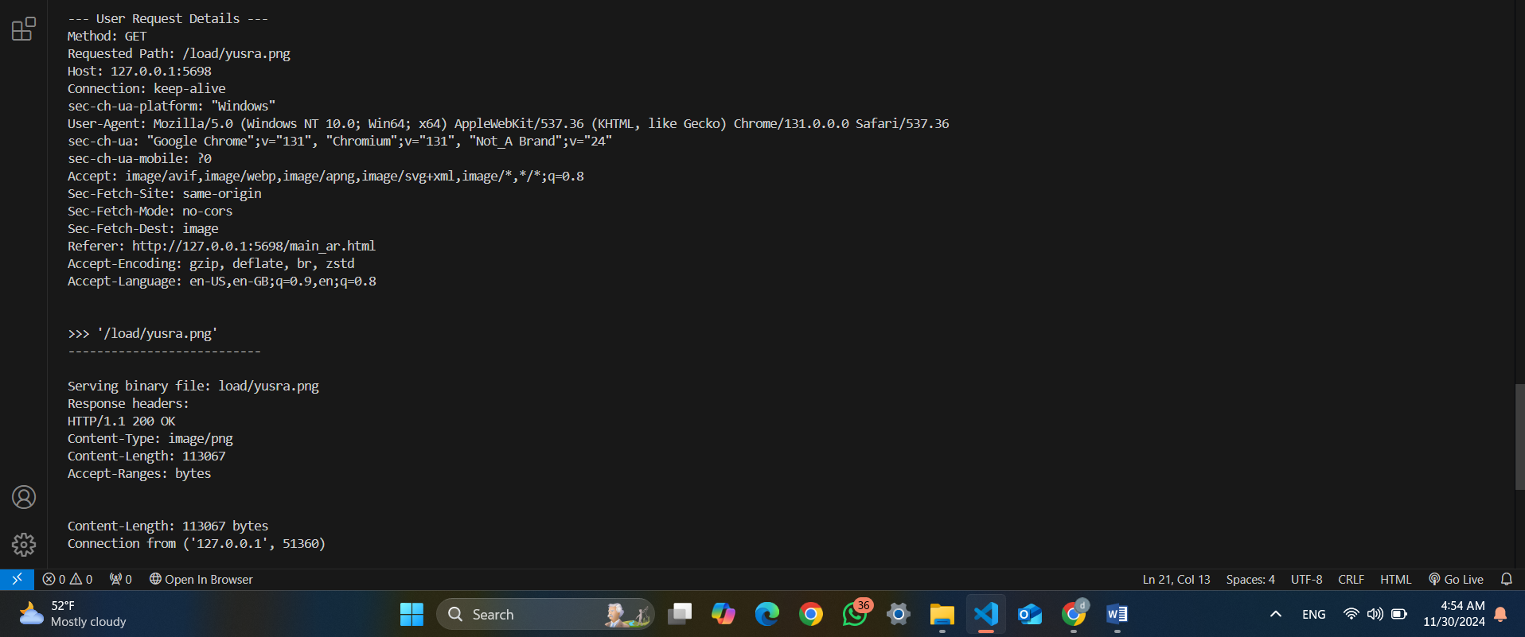figure(40) run main_ar.html page (1)

Request is Image , the server ordered the image on the server (/load/Yusra.png) by Method: GET , Requested Path: /load/ Yusra.png , The server is successfully serving binary files (like images) by reading them in binary mode and sending them to the client with the correct Content-Type. As its print more details such as the Content-Type is image/png that its ordered html page HTTP/1.1 200 OK indicates that the request was successful as the length size is 113067.

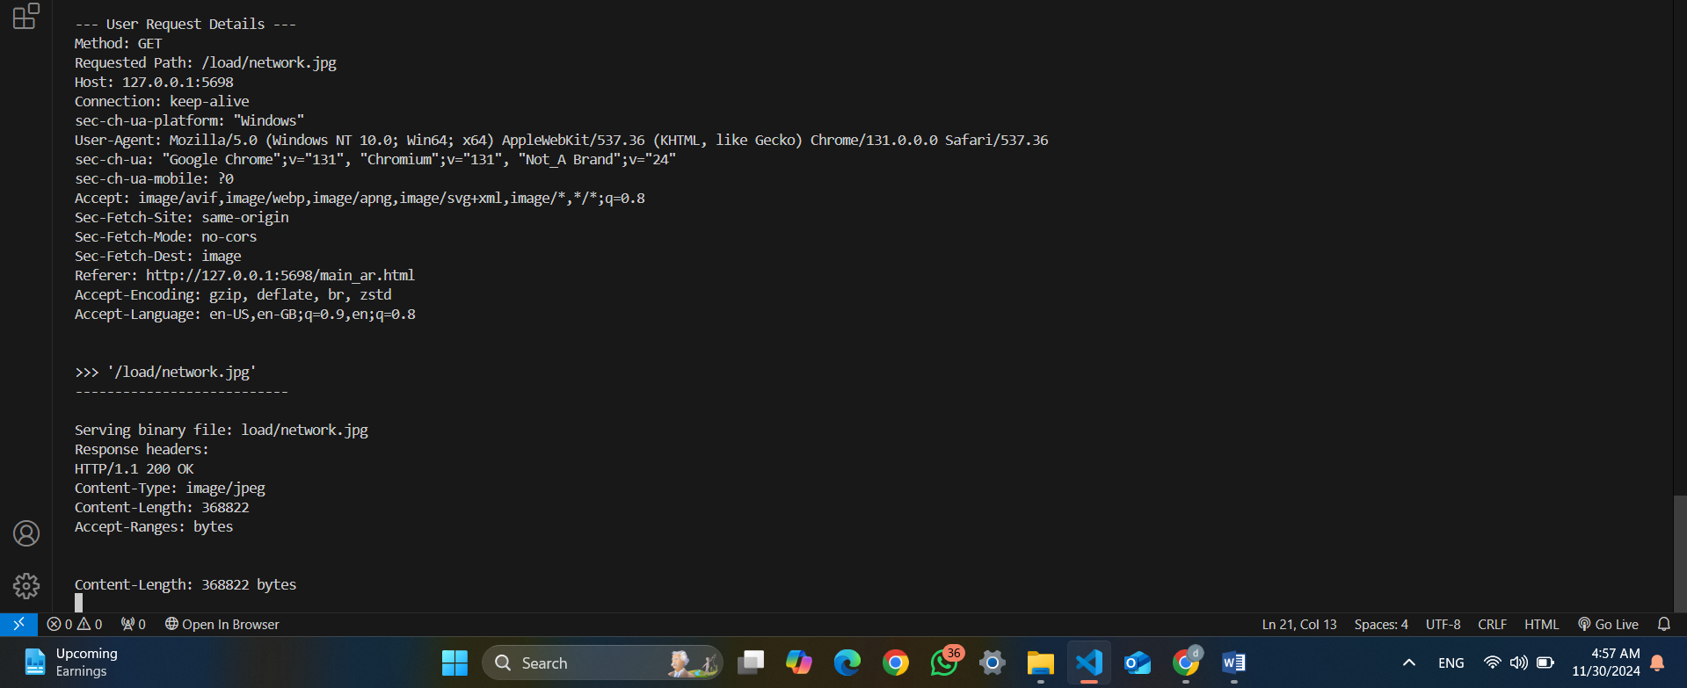figure(41) run main_ar.html page (1)

Request is Image , the server ordered the image on the server (load/network.jpg) by Method: GET , Requested Path: load/network.jpg, The server is successfully serving binary files (like images) by reading them in binary mode and sending them to the client with the correct Content-Type. As its print more details asuch as the Content-Type is image/jpeg that its ordered html page HTTP/1.1 200 OK indicates that the request was successful as the length size is 368822

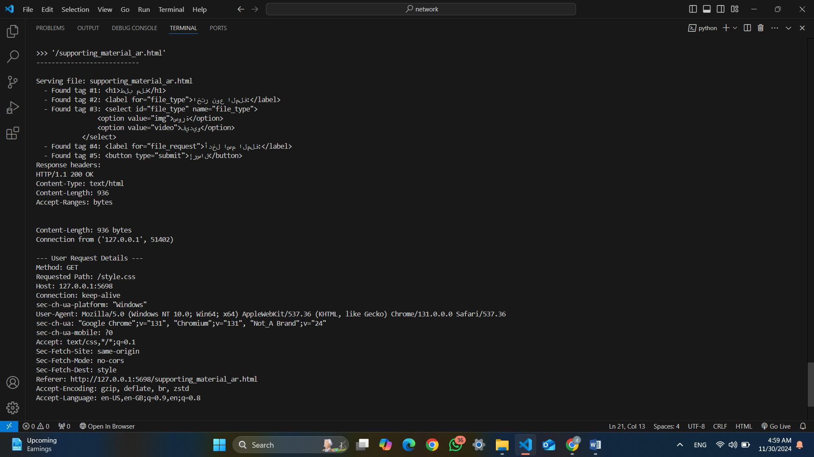figure(42) run supporting_material_ar.html page (1)

Now I order supporting_material_ar.html page first print the content of the html then give me more details about the request . The request was successful, and the file was served without any issues page HTTP/1.1 200 OK indicates that the request was successful as the length size is 936 and the Content-Type is text/html . the server fetch the As its print the details for the file once its ordered the css file for the page by get method that to feach the file

.

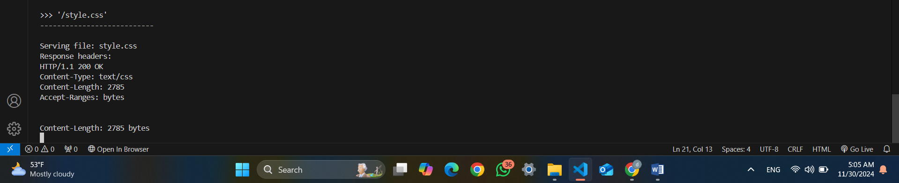figure(43) run supporting_material_ar.html page (2)

Print the file that fetched name style.css as its print the content file is text/css and the size is bytes 2785 and page HTTP/1.1 200 OK indicates that the request was successful .

**the client requests an invalid URL then the results like the following**

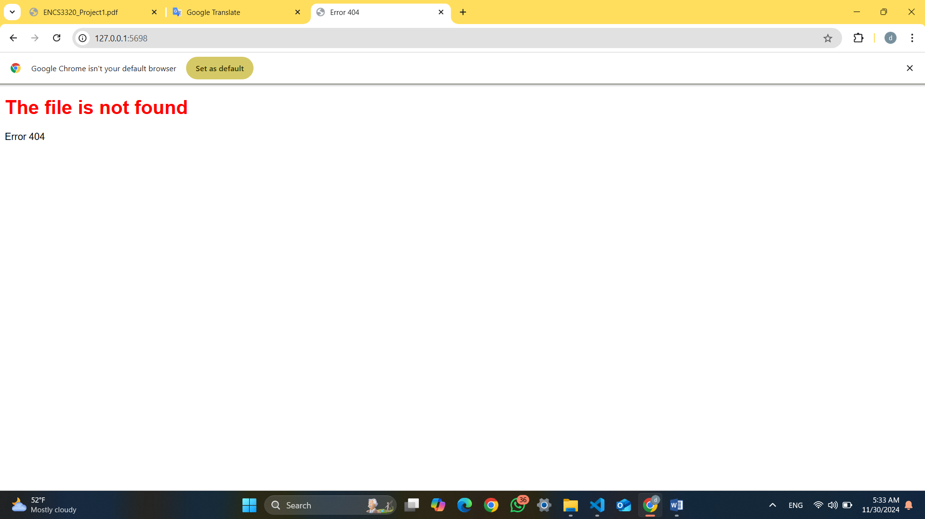figure(45) error on the browser

Since the user enter invalid URL then this is the results on the brwser that display that the file does not found and ther is an error 404 that is mean that the requested resource could not be found on the server

The result on terminal like the following

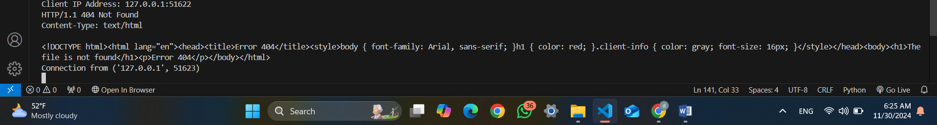figure(46) error on the browser(2)

Because we have invalid URL then we got an 404 erorr so The status line "HTTP/1.1 404 Not Found" Because the url is invalid and the client sends a request to the server using a URL then the server responds with **404** to indicate that the requested resource was not found. Then its print the client’s IP address and port number is 127.0.0.1:51622 .

Now the clients when his ordered a video for https.mp4 we got the following results on the terminal

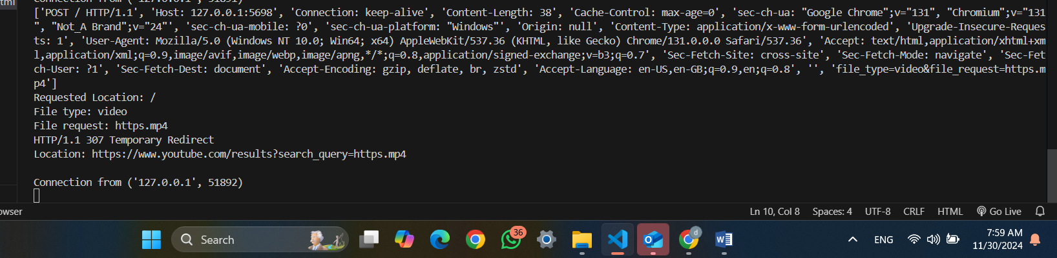figure(46) results on the terminal(2)

Now the client ordered a video for https.mp4 that does not exists on the server so that its redirect the client to a site according to clients search , now we redirect thee client by 307 Temporary Redirect(Specifies the URL to which the request should be redirected to another URL ) so that http/1.1 is by 307 Temporary Redirect and the redirect URL is <https://www.youtube.com/results?search_query=https.mp4> ts mean the following ,, https://www.youtube.com/results: This is the base URL for YouTube’s search results pag ?search_query=https.mp4: This part of the URL includes a query parameter (This is the parameter that tells YouTube what to search for ) followed by the value https.mp4 e. When you access this URL, YouTube shows the results for a query you include in the URL and https.mp4: This is the search term YouTube will use to find videos .

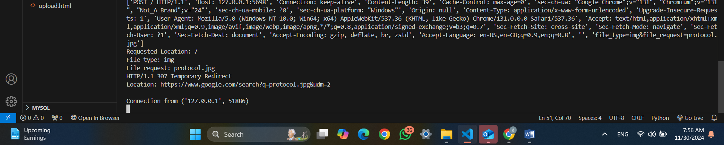 figure(46) results on the terminal(2)

When the client request protocol image since its not on the server then its now we redirect thee client by 307 Temporary Redirect(Specifies the URL to which the request should be redirected to another URL ) so that http/1.1 is by 307 Temporary Redirect and the redirect URL is <https://www.google.com/search?q=protocol.jpg&udm=2> , https://www.google.com/search: This is the base URL for Google’s search functionality. It directs you to the Google search results page. q: This is the parameter for the search term , protocol.jpg: This is the term Google will search for , &udm=2 its an additional parameter to search for image on google

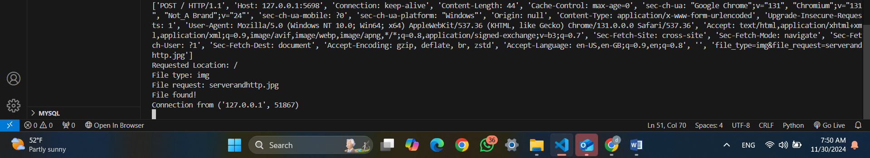 figure(46) results on the terminal(2)

Hear when the use searched for serverandhttp.jpg that is its on the server its print that’s is the image has been founded and the file type is img and using post method to send the data with size 44 on http/1.1 on the port 5698 ….

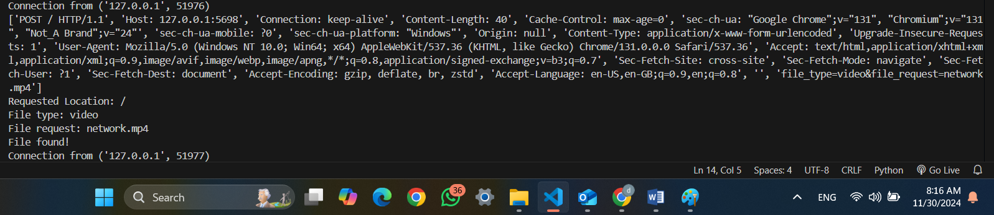figure(47) results on the terminal(2)

Hear the user order a video network.mp4 that exists on the server , using post method , on windows ,opened by chrome file type video and the file found on the server .

### **test on the phone**

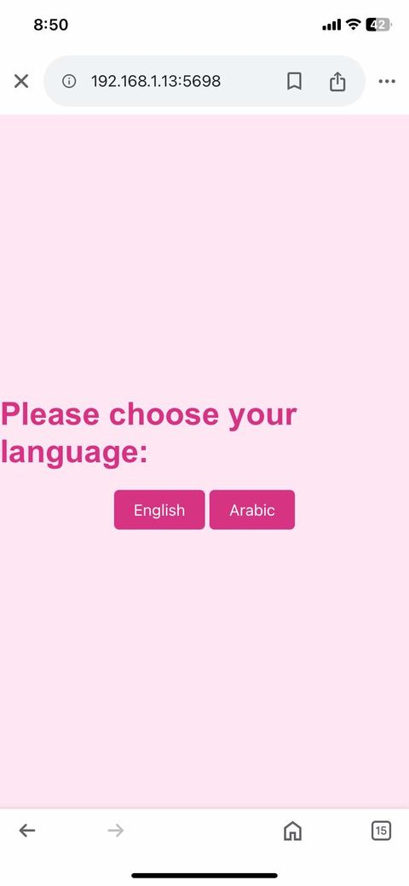

figure(48) phone test

as we can see its running now on the phone and this is the first page .

figure(49) phone test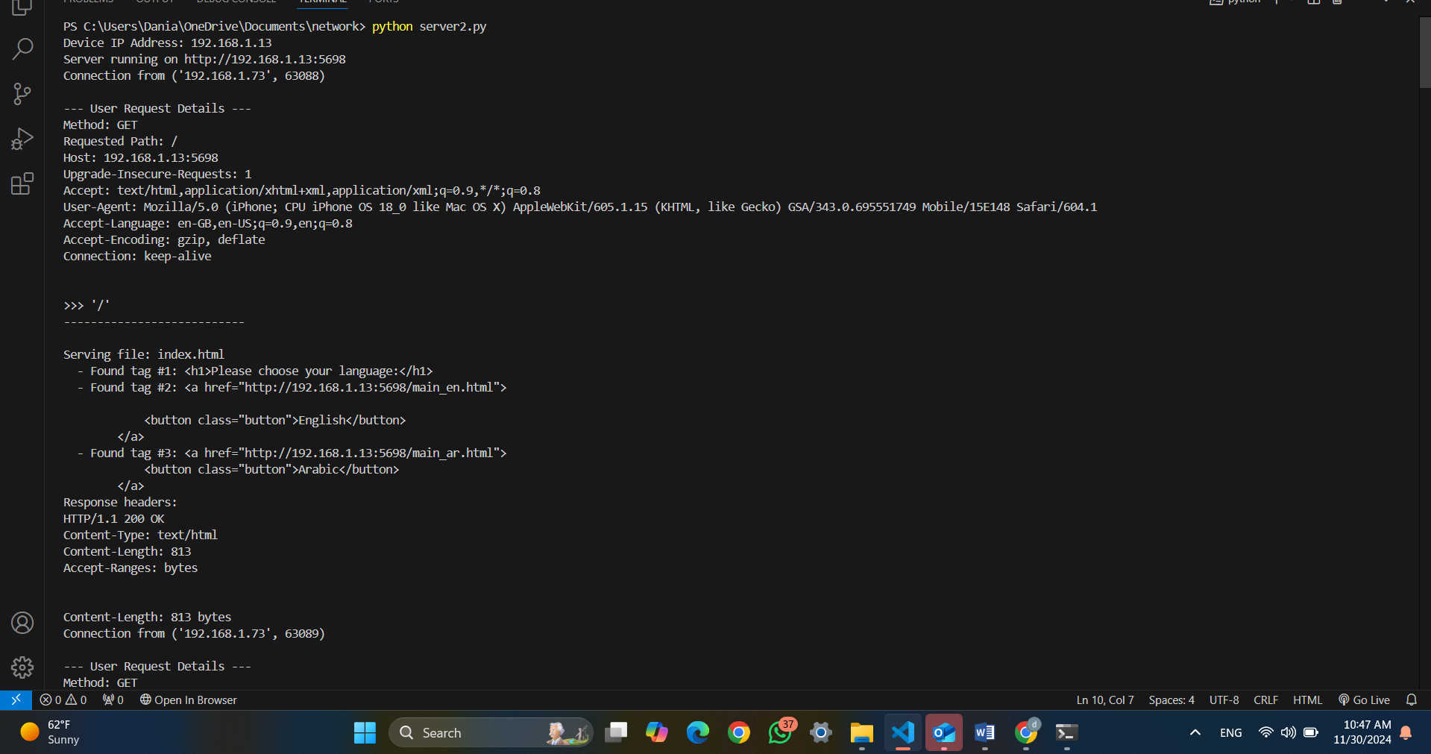 figure(49) phone test

the ip address for my laptop is 192.168.1.13 and we connected from phone by http request <http://192.168.1.13:5698> , and the IP address for the phone that was connected is 192.168.1.73 .

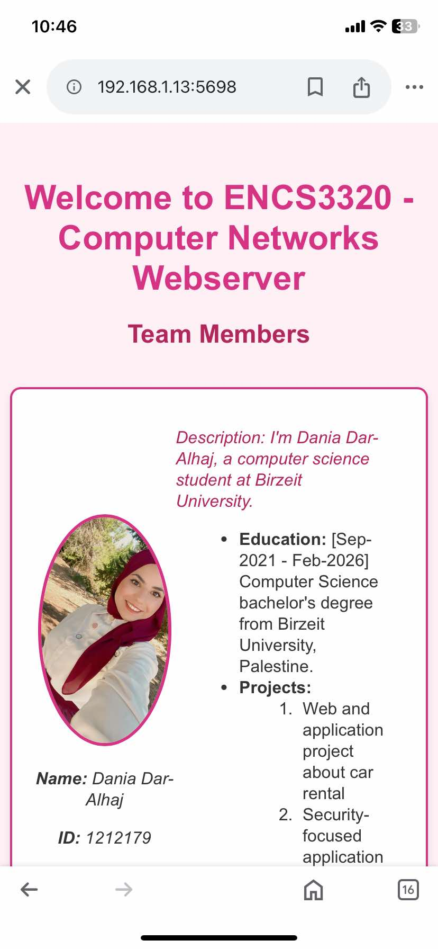

figure(50) phone test

hear as you can see the test successful on the main_en.html

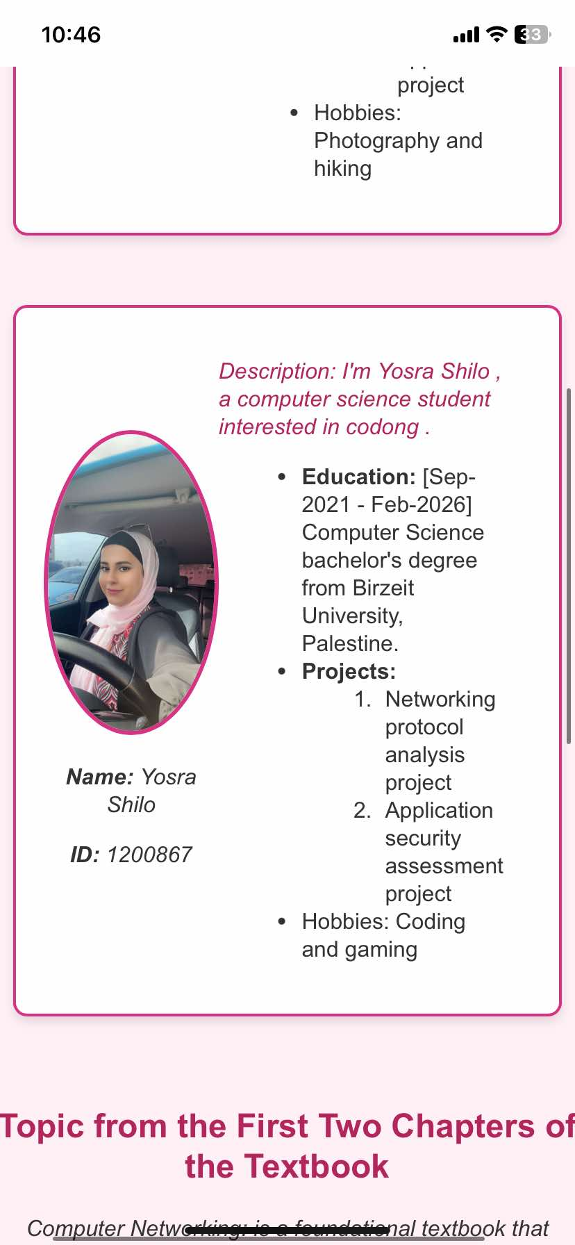

figure(51) phone test

hear as you can see the test successful on the main_en.html

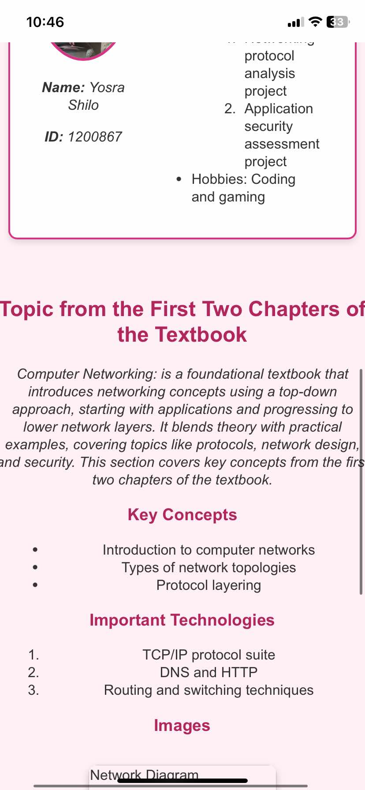

figure(52) phone test

hear as you can see the test successful on the main_en.html

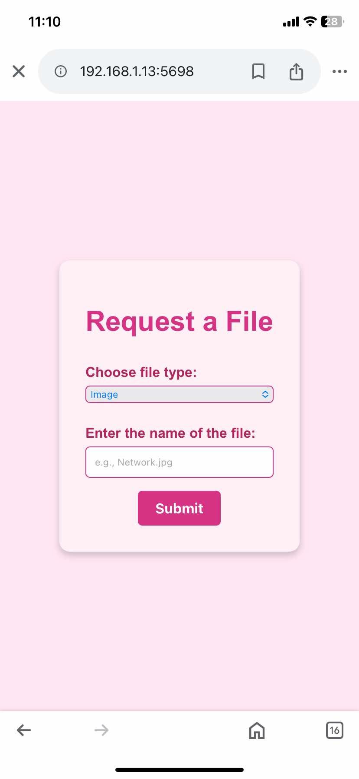

figure(53) phone test

hear as you can see the test successful on the main_en.html

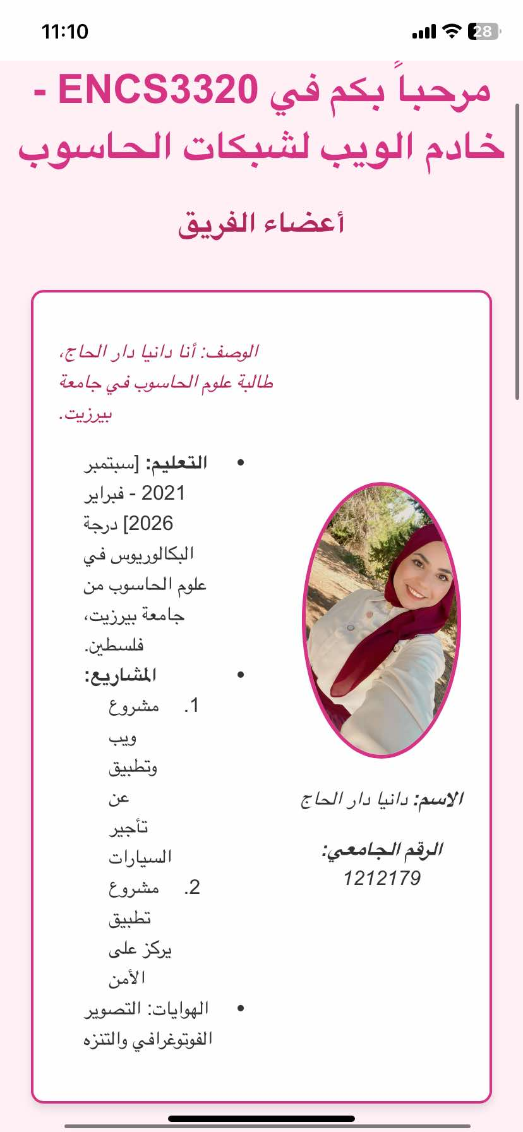

figure(54) phone test

hear as you can see the test successful on the main_en.html

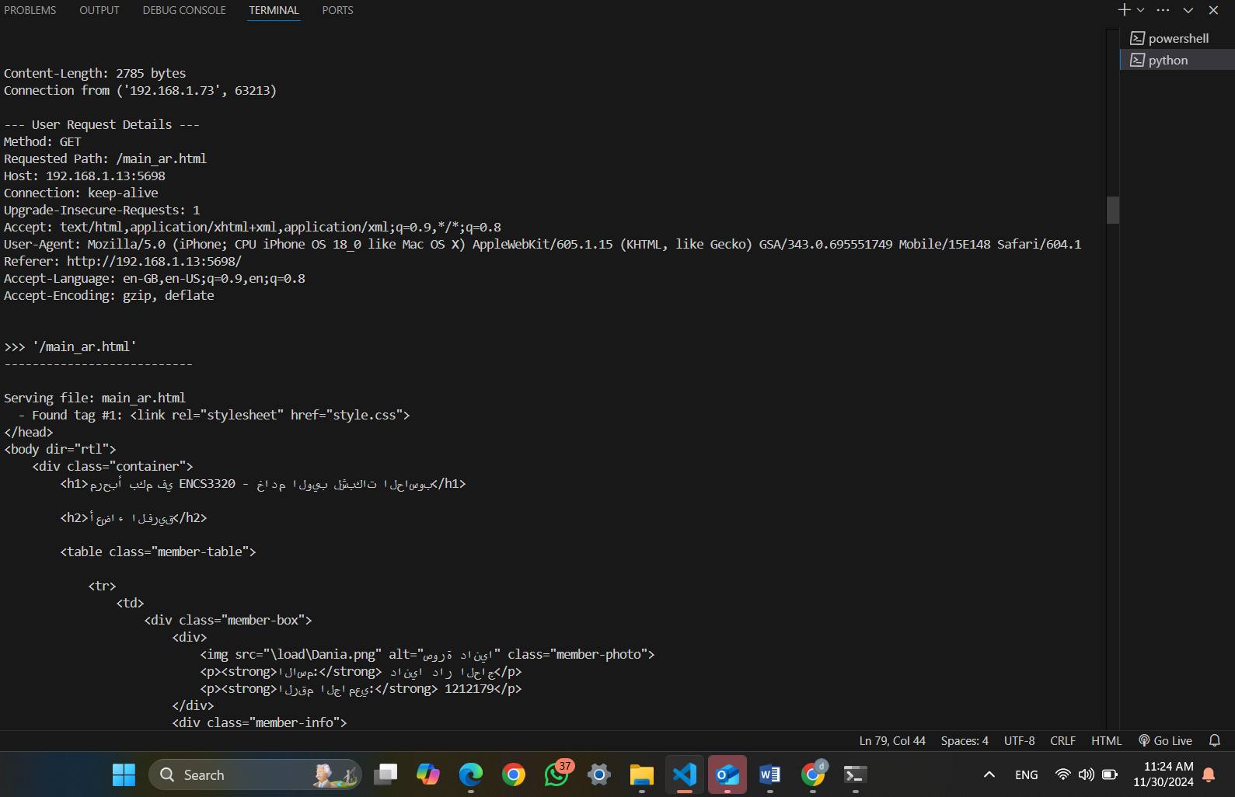 figure(55) phone test

Hear when order the Arabic language the results like above but connecting device is 192.168.1.73 and it’s a phone that ordered the page and some of detailed request

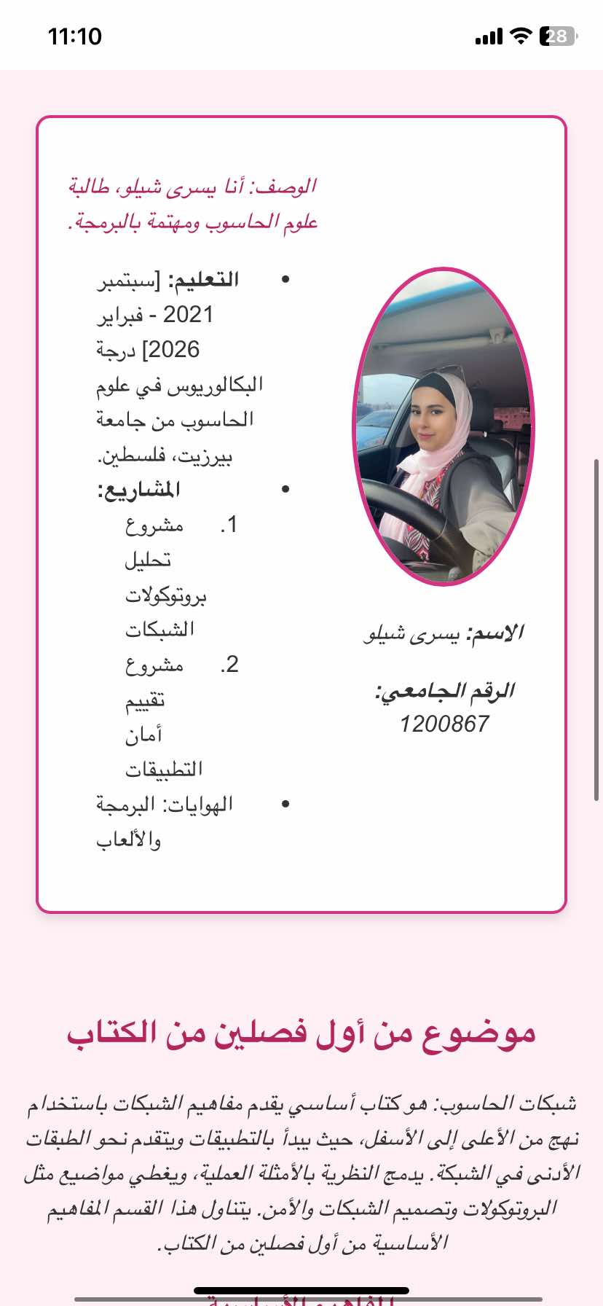

figure(56) phone test

hear as you can see the test successful on the main_ar.html

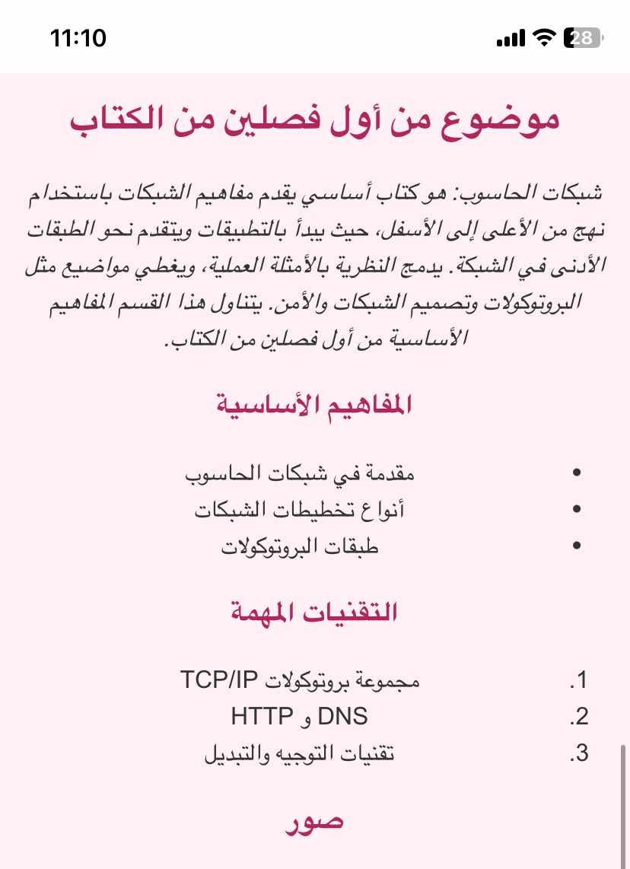

figure(57) phone test

hear as you can see the test successful on the main_ar.html

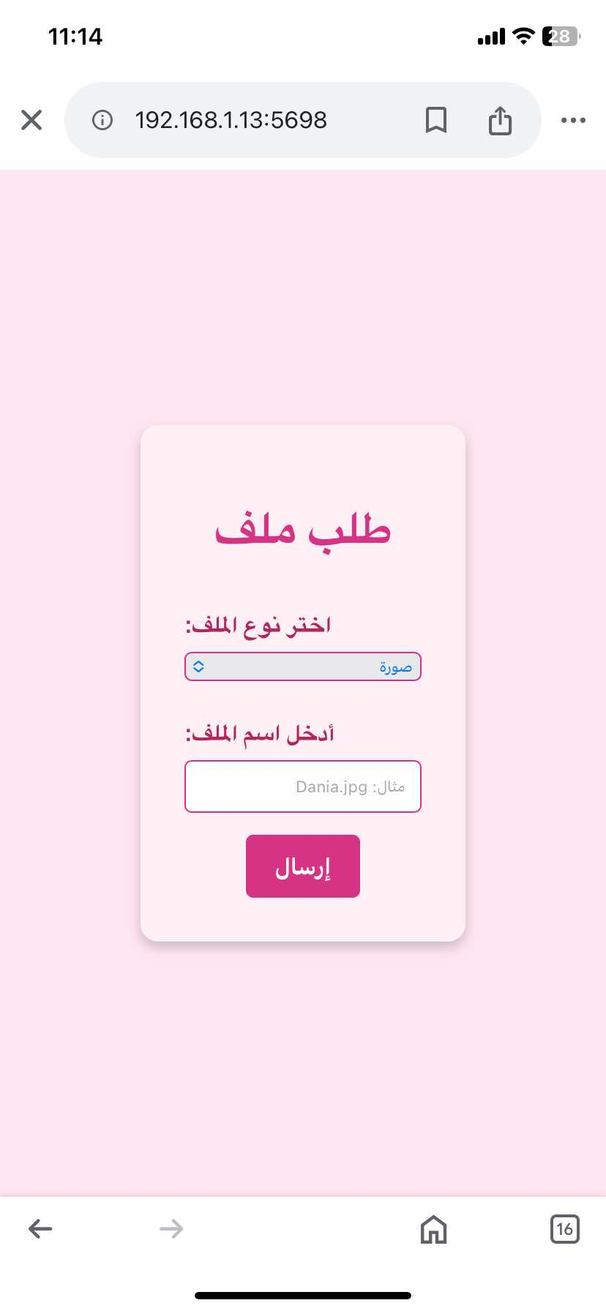

figure(58) phone test

hear I ordered supporting_material_ar.html on phone and the following results on terminal

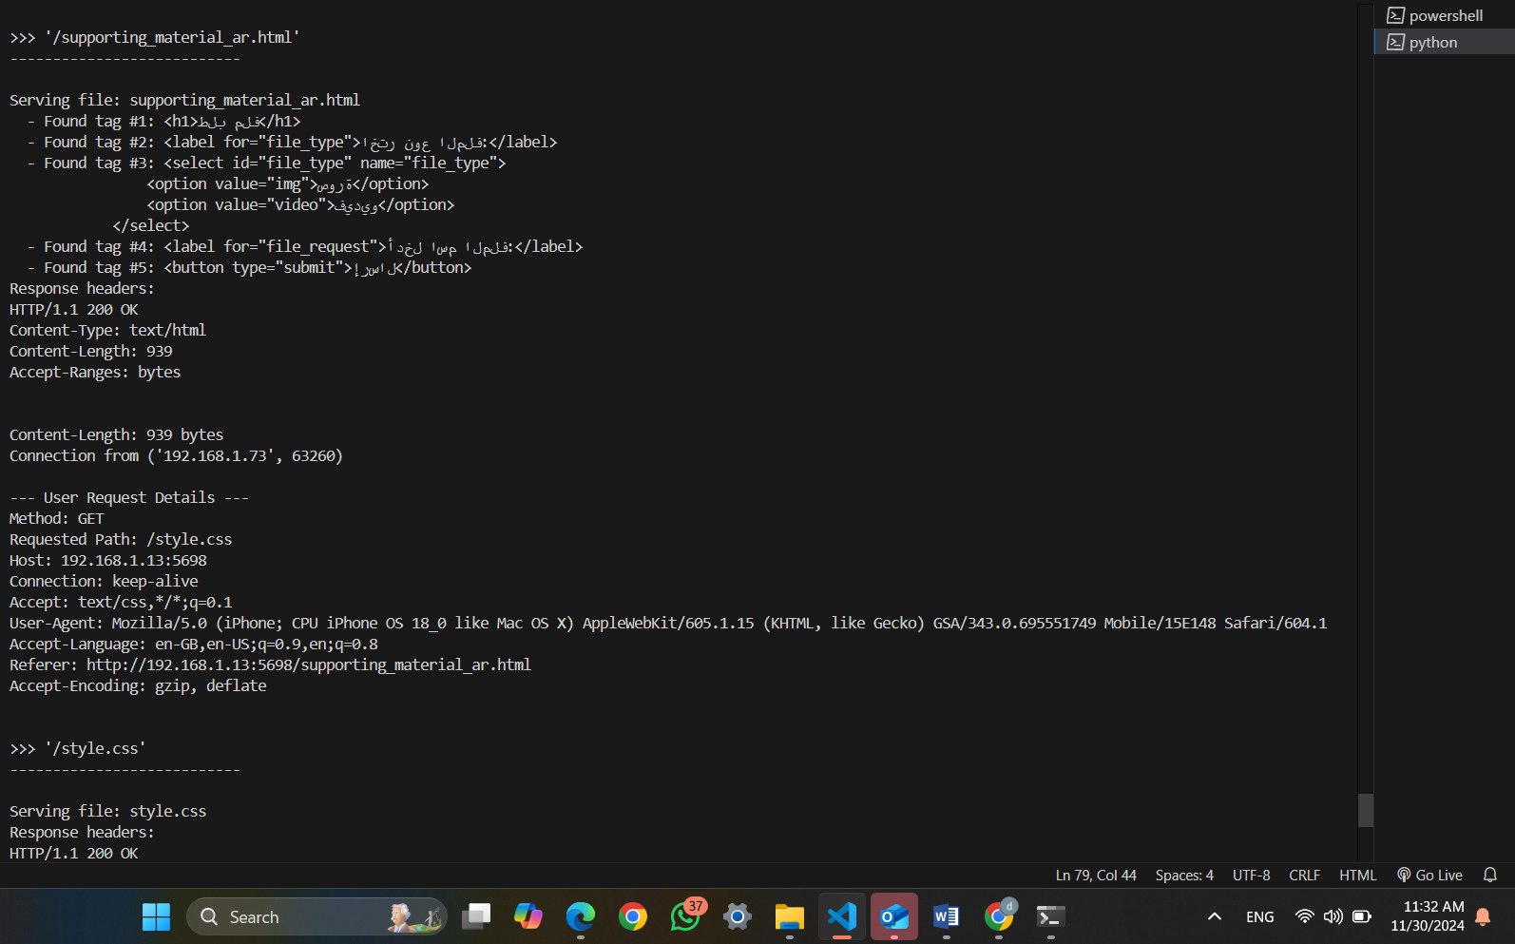 figure(59) phone test

Not I don’t provide all details for the terminal on phone I put the must important photo becous the results the same but the only difference ip number that I provided above

**Code for task2**

**Code for task2**

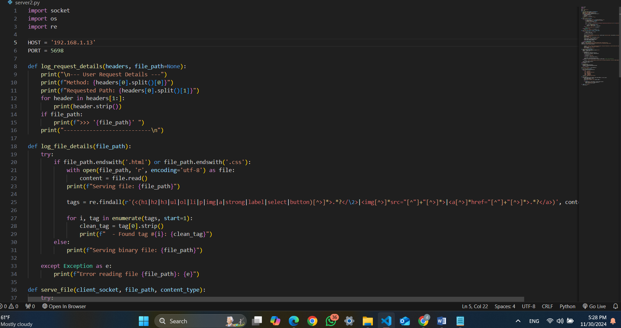

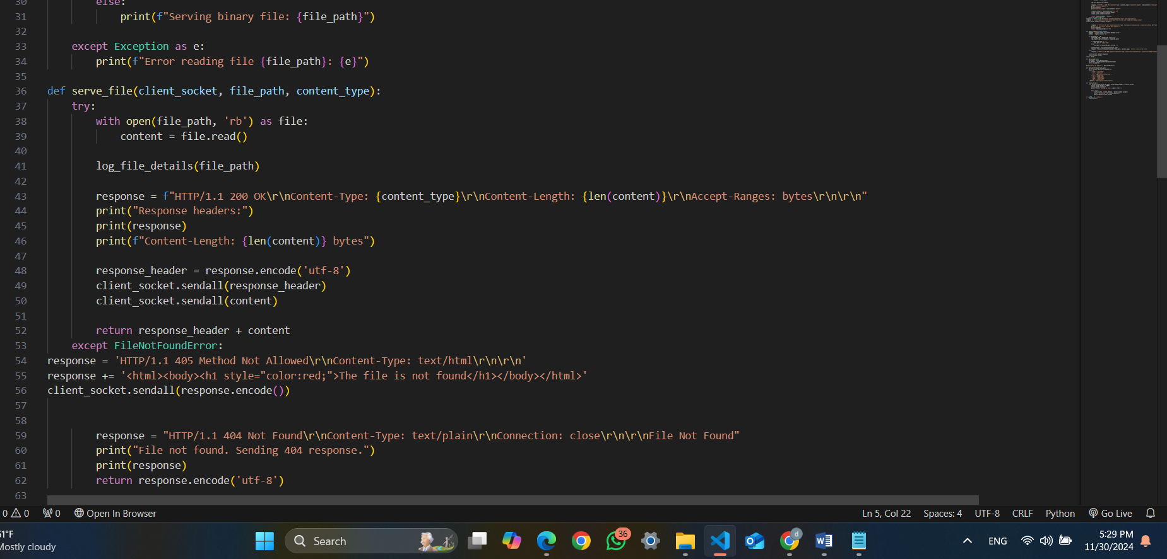

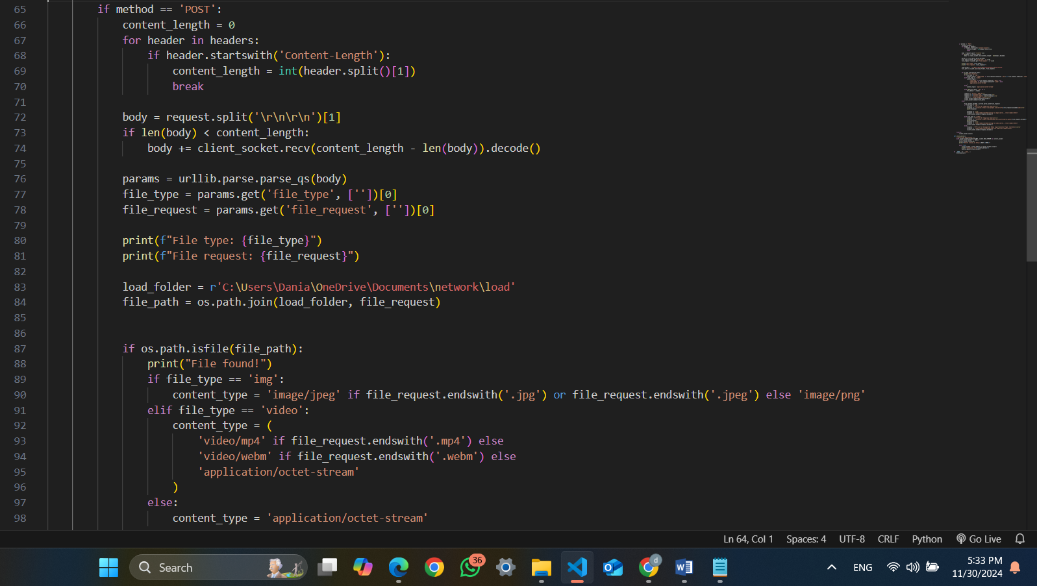

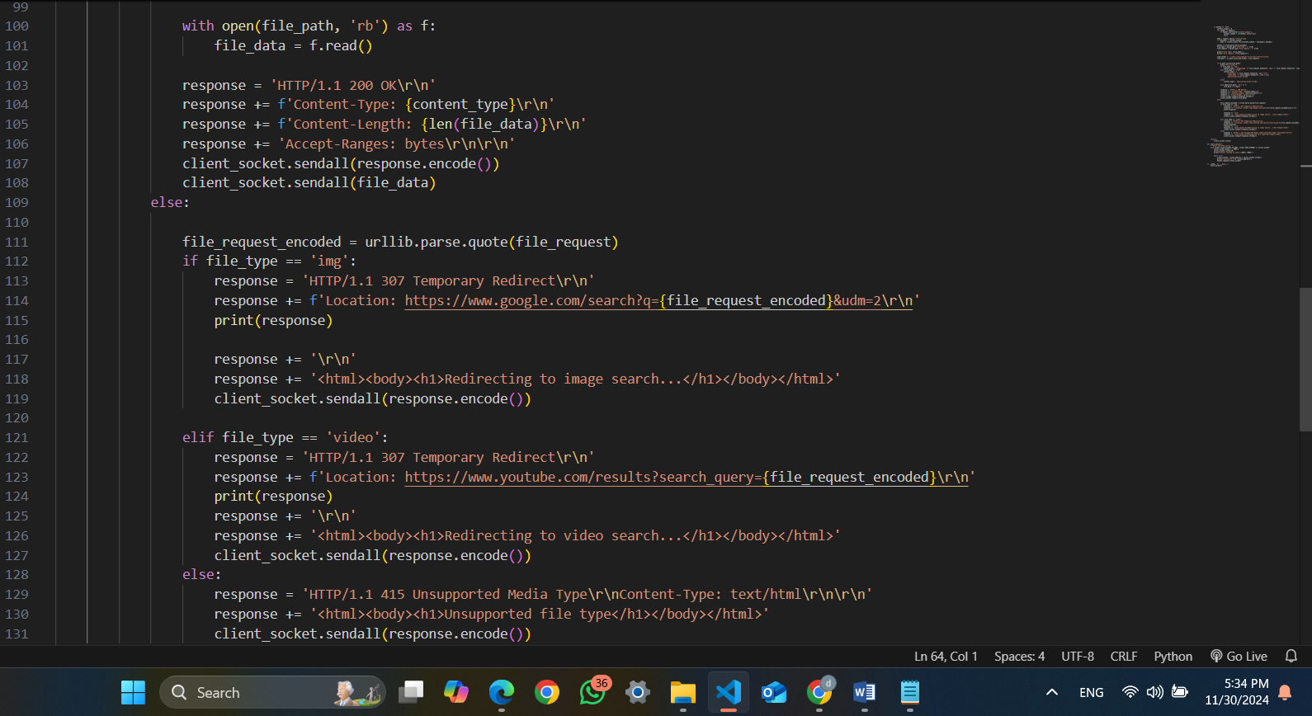

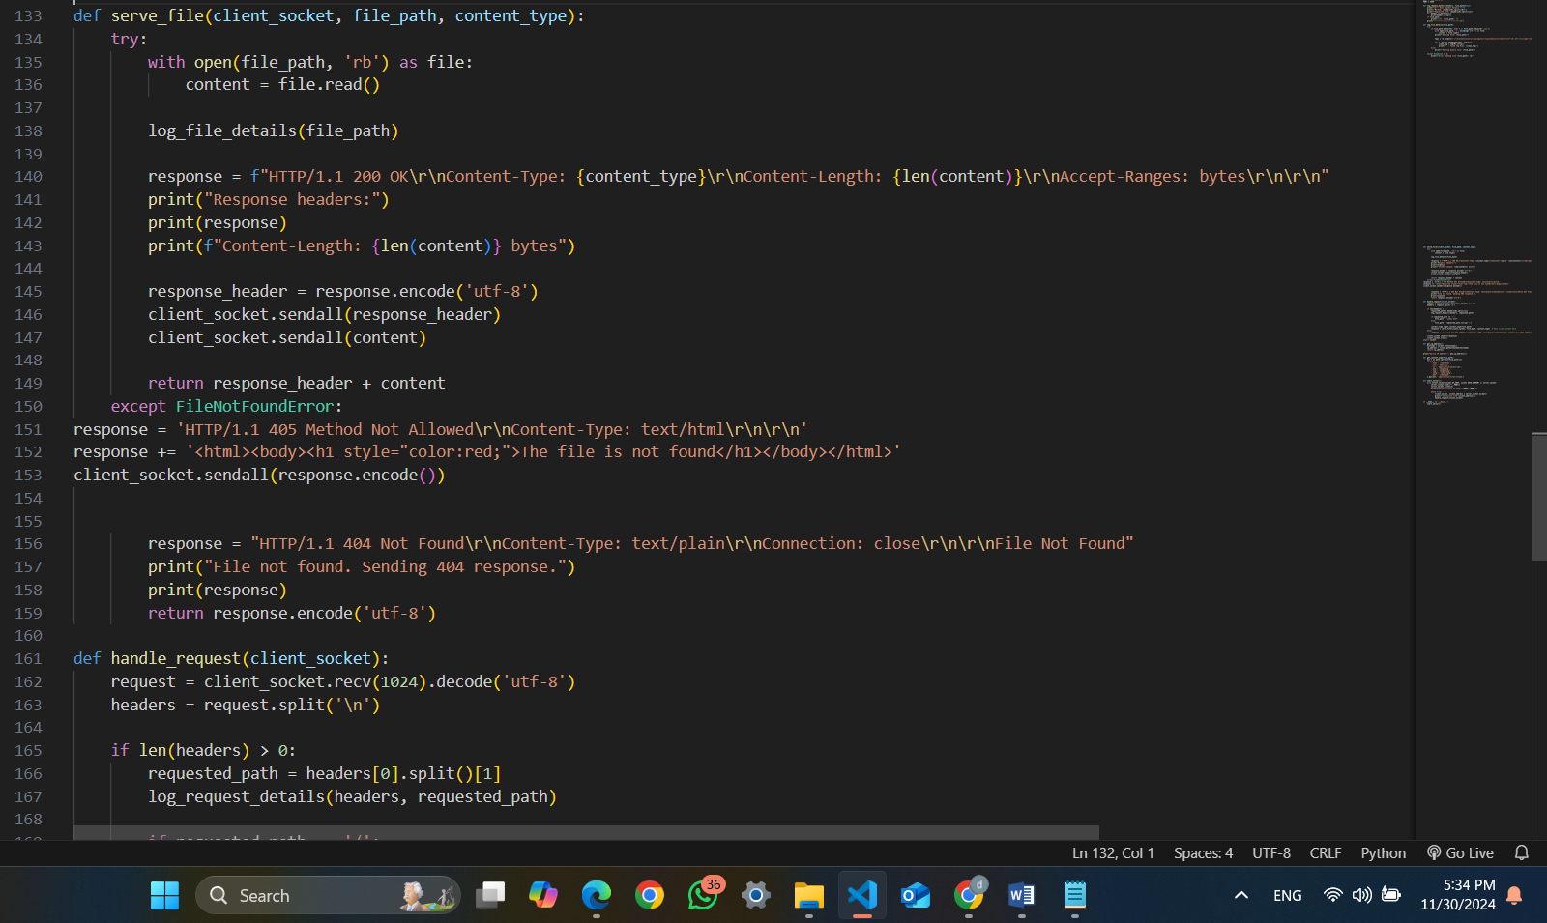

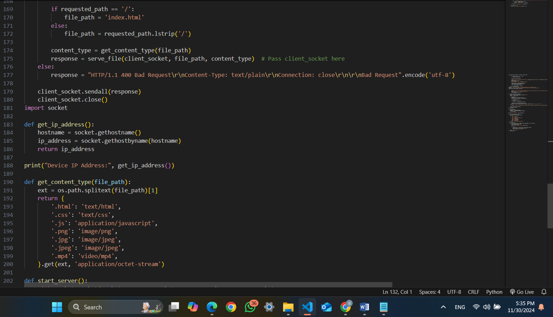

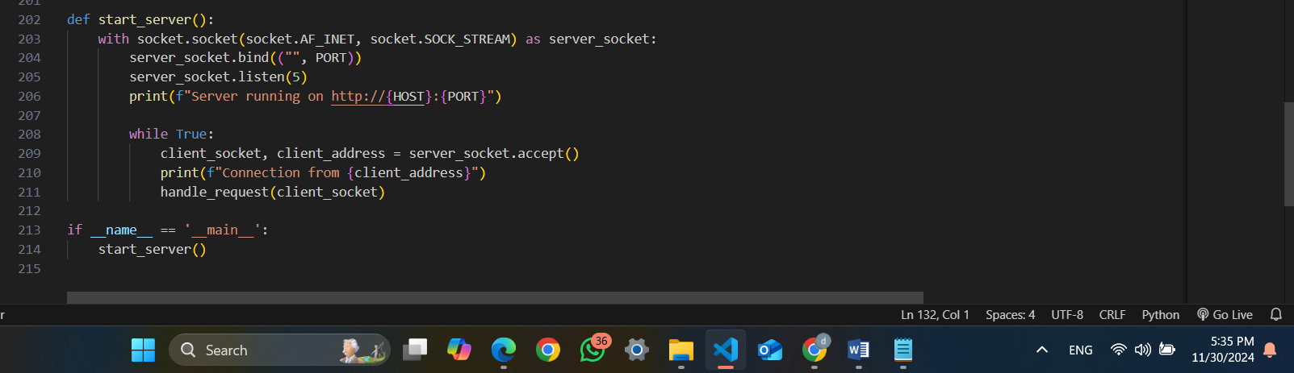 do as well that handle all possible case and as i explain in the flowchart the server have a several ordered page and the server for each time requast a page its genarate also the scc for styling and the code handl the cacess for the client when the client order Images and Videos , If the requested file is unavailable Images: Redirects to Google Image Search with a query parameter that i used https://www.google.com/search?q=file_name&udm=2 to redirect the user to a photos on google according client research . Videos: Redirects to YouTube Video Search on the following request https://www.youtube.com/results?search_query=file_name as the code . we have three HTTP status codes that i handled in my case with working with wep that each one is indicate the result of the request : 200 OK status signifies a successful request , in my case its the status for all successful request. The 307 Temporary Redirect code informs the client to redirect to another URL while maintaining the original request method that if the request is get will still get and if its post will stil post , its a way that i use it to redirect the client to another request that if the client order photo or video not on the server the http request the status will be 307 Temporary then i redirect the client to another URL according to the request. 404 Not Found code indicates that the requested resource is unavailable, and 415 Unsupported Media Type is returned when the server cannot process the request due to an unsupported file format. and in my case the status was 404 when get a wrong http request or anything that i cant manage it because its a wrong request 404 will happen .

### **Theory and Procedure for task 2**

**Code for taske 3**

|  |  |  |
| --- | --- | --- |
| **Yusra** | **Dania** | **Task** |
| **A – (iv) (v) with rebort**  **B – nslookup**  **telnet**  **C – second and thired picture with report** | **A – (i) (ii) (iii) with report**  **B – ip config / all**  **Ping foe wep**  **Ping for device**  **Tracer**  **C- first picture with report** | **Task1** |
| **C – yusra with report**  **Server Functionality with report** | **A – do it with report**  **B – do it with report**  **If the client requests an invalid URL with report** | **Task2** |
| **A and B with report** | **C and D with report** | **Task3** |